Standing On The Corner (Frank Loesser, 1956)
Standing On Corner by The Four Lads (1958)
Version 1

Intro G Gm Eb C . . G Bb Eb Ab  G C D Eb Ab  Standing on the corner watching all the girls go by.  G C A Am7 D  Standing on the corner watching all the girls go by.  D Gm7 G C  Brother you don't know a nicer occu-pation,  Eb D  Matter of fact, neither do I.  G D C  Than standing on the corner watching all the girls,  G A G C B  Watching all the girls, watching all the girls, go by.  Bridge 1  Em7 C Em7 C Em7 C Em7 C  I'm the cat that got the cream, haven't got a girl but I can dream.  G C Am7 G Ab  Haven't got a girl but I can wish. So, I take me down to Main Street  G Db A C D  And that's where I select my imaginary dish.  G C D Bb Eb Ab  Standing on the corner watching all the girls go by.  G C A C D  Standing on the corner giving all the girls the eye.  G C  Brother if you've got a rich imagi-nation,  Ab D  Give it a whirl, give it a try.  G C  Try standing on the corner watching all the girls,  G A G Em7 B  Watching all the girls, watching all the girls go by. | 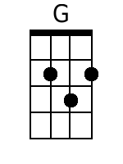 | 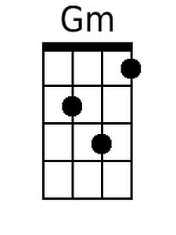
 | 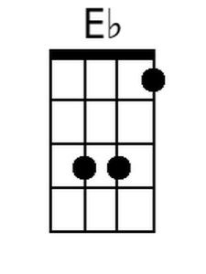 | 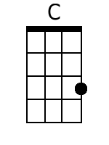
 | 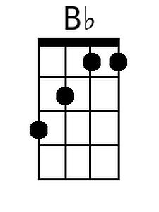 | 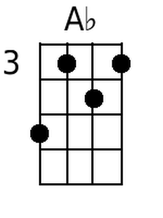
 | 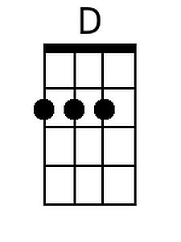 | 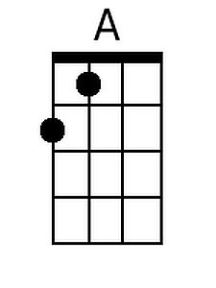
 | 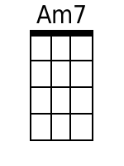 | 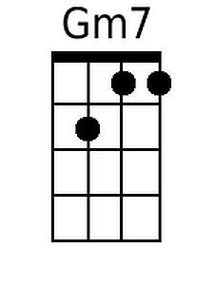
 | 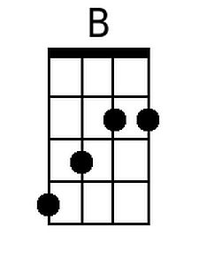 | 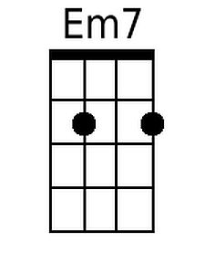
 | 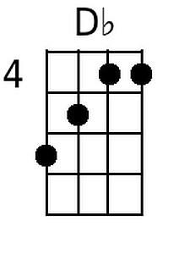 | 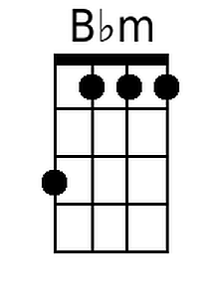
 | 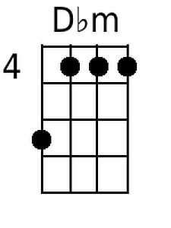 | 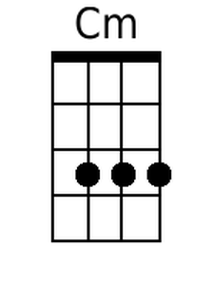

Standing On Corner – Page 2

Baritone Chords
Bridge 2  Em7 C Em7 C Em7 C Em7 C  Satur-day and I'm so broke, haven't got a girl and that's no joke.  G C Am7 G Ab  Still I'm living like, a million-aire, when I take me down to Main Street,  G Db A Bbm Ab  And I review the harem parading for me there.  Ab Db Dbm Cm B A  Standing on the corner watching all the girls go by.  Ab Db Bbm Dbm Eb  Standing on the corner underneath the springtime sky.  Eb Ab Db  Brother, you can't go to jail for what you're thinking.  Bbm Eb  Or for the woo (wolf whistle) look in your eye.  Outro  Eb Ab Eb Db  You're only standing on the corner watching all the girls,  Ab Bb Eb  Watching all the girls, watching all the girls,  Ab Db Ab  (long wolf whistle)..go byyyyyyyyyyyyy. | 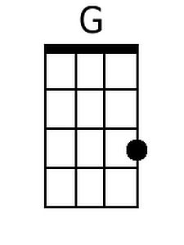 | 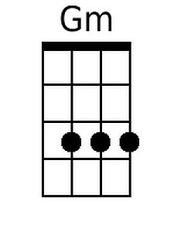
 | 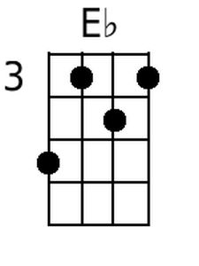 | 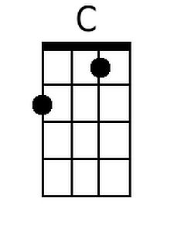
 | 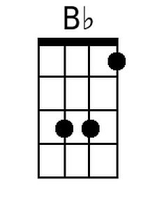 | 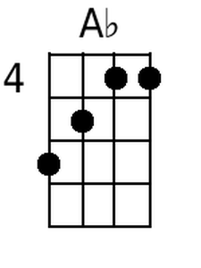
 | 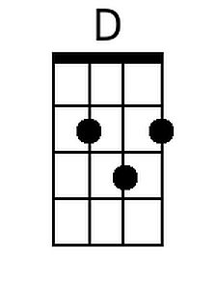 | 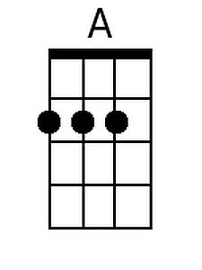
 | 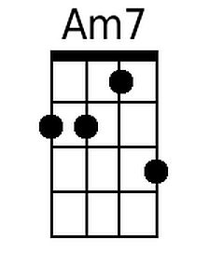 | 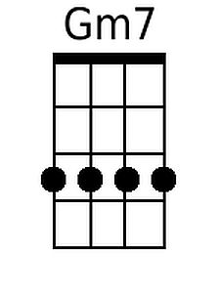
 | 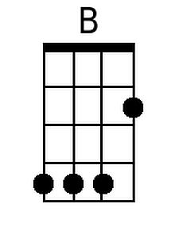 | 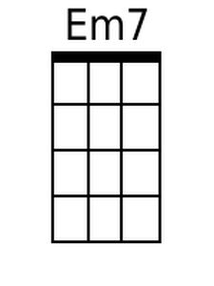
 | 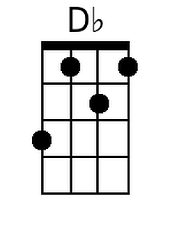 | 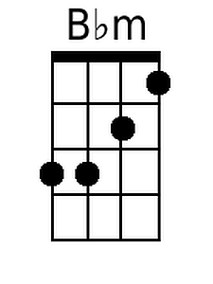
 | 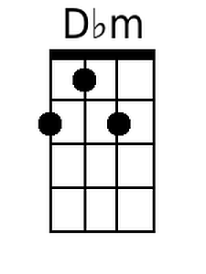 | 