**Stormy Weather (Harold Arlen, Ted Koehler)**

**Intro: G Em Am7 D7**



G



Am7

Em

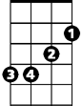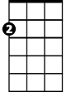

Am

E7

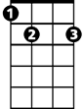

A7

**G Dm6 Am D7**

Don't know why there's no sun up in the sky

**G Em7**

Stormy weather

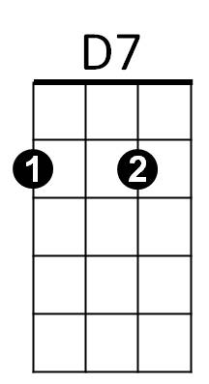**Am7 D7 G Em**

Since my gal and I ain't to-gether,

**Am7 D7 G Em Am7 D7**

Keeps rainin' all the time

**G Dm6 Am D7**

Life is bare, gloom and misery every-where

Em7

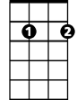

**G Em7**

Stormy weather

**Am7 D7 G Em**

Just can't get my poor self to--gether,

**Am D7 G Em Am7 D7**

I'm weary all the time

**D7 G Em Am7 D7**

So weary all the time

**Am D7 G Em**

When she went away the blues walked in and met me.

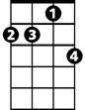

Am7

**BARITONE**



G



Em

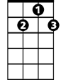

D7



Em7



E7

**Am D7 G Em**

If she stays away old rockin' chair will get me.

**Am D7 G E7**

All I do is pray the Lord above will let me,

**A7 D7**

Walk in the sun once more.

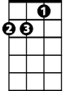

Am

**G Dm6 Am D7**

Can't go on, every thing I had is gone

**G Em7**

Stormy weather

**Am7 D7 G Em**

Since my gal and I ain't to-gether,

**Am D7 G Em Am7 D7**

Keeps rainin' all the ime

**Am D7 G Em Am7 D7 G**

Keeps rainin' all the time