**Stray Cat Strut (The Stray Cats)**



G

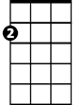

Am

**Intro: Am G F E7 (2x)**

Oooh Oooh Oooh Oooh

**Am G F E7 Am G F E7**

Black and orange stray cat sittin' on a fence.

E7

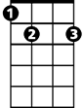

F



**Am G F E7 Am G F E7**

Ain't got enough dough to pay the rent.

**Am G F E7 Am (tacet)**

I'm flat broke but I don't care ~ I strut right by with my tail in the air.

**Dm C Bb A7**

Stray cat strut I'm a ladies’ cat,

**Dm C Bb A7**

I'm a feline Casanova hey man that's that.

**Dm C Bb A7** **Dm (tacet)**

Get a shoe thrown at me from a mean old man ~ Get my dinner from a garbage can.

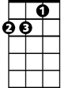

Dm



C



Bb

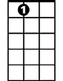

A7

**(Instrumental)** **Am G F E7 (4x)**

**Dm Am**

I don't bother chasing mice around.

**Dm**

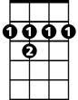

B7

I slink down the alley looking for a fight

**B7 E7**

Howlin' to the moonlight on a hot summer night.

**Am G** **F E7**

Singin' the blues while the lady cats cry.

**Am G F E7**

Wow stray cat you're a real gone guy.

**Am G F E7 Am (tacet)**

I wish I could be as care-free and wild ~ But I got cat class and I got cat style.

**Am G F E7 (4x) Am**

**(repeat last verse )**

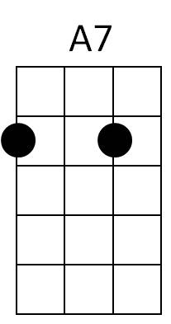**Am G F E7 (3x) Am G E7 Am**

B7

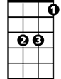

Bb

C

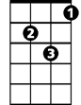

Dm



E7



F



G



Am

**BARITONE**