**While Strolling Through the Park One Day (Ed Haley 1884)**



C



G

**G C**

While strolling through th e park one day,

**A7 D7**

In the merry, merry month of May,

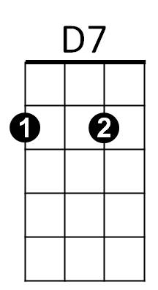 **G C A7**

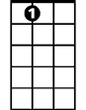

A7

He was taken by surp rise by a pair of roguish eyes,

**D7 G**

In a moment his poor heart was stole away.

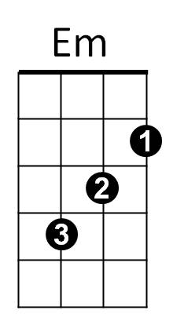 **B Em B7 Em**

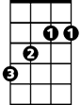

B

A smile was all she gave to him,

**A D A7 D**

Of course she was as happy as can be,

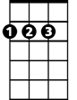

D

**G C**

He immediately raised his hat,

**A7 D7**

And finally she remarked,

**G C A7**

He never will forget that lovely afternoon,

**D7 G**

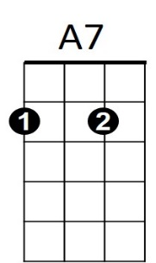He met her at the fountain in the park.



D

B7

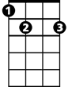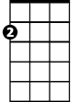

Em

B

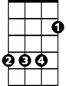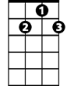

D7

C



G

**BARITONE**