**Suddenly Last Summer (Martha Emily Davis) Key A**

**A**

It happened one summer, it happened one time

**G A**

It happened forever, for a short time

A place for a moment, an end to a dream

**G A**

Forever I loved you, forever it seemed

**Chorus:**

**D Dm A**

One summer never ends, one summer never began

**D Dm A**

It keeps me standing still, it takes all my will

**G Bm A**

And then suddenly last summer

**A**

Sometimes I never leave, but sometimes I would

**G A**

Sometimes I stay too long, sometimes I would

Sometimes it frightens me, sometimes it would

**G A**

Sometimes I'm all alone and wish that I could

**(Chorus)**

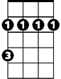

Bm

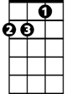

Dm

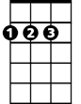

D



G

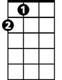

A

**G Bm A**

And then suddenly last summer

**(second verse)**

**(Chorus)**

**G Bm A**

**BARITONE**

And then suddenly last summer



G



D

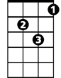

Dm



A

Bm

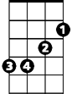

**G Bm A**

Until suddenly last summer

**G Bm A**

And then suddenly last summer

**G Bm A**

Until suddenly last summer

**Suddenly Last Summer (Martha Emily Davis) Key G**

**G**

It happened one summer, it happened one time

**F G**

It happened forever, for a short time

A place for a moment, an end to a dream

**F G**

Forever I loved you, forever it seemed

**Chorus:**

**C Cm G**

One summer never ends, one summer never began

**C Cm G**

It keeps me standing still, it takes all my will

**F Am G**

And then suddenly last summer

**G**

Sometimes I never leave, but sometimes I would

**F G**

Sometimes I stay too long, sometimes I would

Sometimes it frightens me, sometimes it would

**F G**

Sometimes I'm all alone and wish that I could

**(Chorus)**

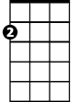

Am

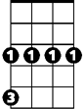

Cm



C

F



G

**F Am G**

And then suddenly last summer

**(second verse)**

**(Chorus)**

**F Am G**

**BARITONE**

And then suddenly last summer



Am

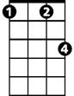

Cm

C



F



G

**F Am G**

Until suddenly last summer

**F Am G**

And then suddenly last summer

**F Am G**

Until suddenly last summer