Suicide is Painless (Johnny Mandel and Mike Altman, 1970)
Theme from M.A.S.H. - Key Am

Intro: Am  Dm7 G7 C Am  Through early morning fog I see, visions of the things to be  Dm G7 C Am7 A7  The pains that are with-held for me, I realize and I can see,  Refrain  Dm7 G7 C Am7  That suicide is painless, it brings on many changes  Fmaj7 Em Dm G7 Am Am  And I can take or leave it if I please  Dm7 G7 C Am  I try to find a way to make all our little joys relate  Dm G7 C Am7 A7  Without that ever present hate. But now I know that it's too late, and, Refrain  Dm7 G7 C Am7  The game of life is hard to play, I'm gonna lose it anyway  Dm G7 C Am7 A7  The losing card I'll someday lay, so this is all I have to say . Refrain  Dm7 G7 C Am7  The only way to win is cheat, and lay it down before I'm beat  Dm G7 C Am7 A7  And to another give my seat for that's the only painless feat . Refrain  Dm7 G7 C Am7  The sword of time will pierce our skins, it doesn't hurt when it begins  Dm G7 C Am7 A7  But as it works its way on in the pain grows stronger watch it grin, Refrain  Dm7 G7 C Am7  A brave man once requested me to answer questions that are key  Dm G7 C Am7 A7  Is it to be or not to be ? And I replied 'Oh, why ask me? Refrain  Em Dm G7 Am Am  And you can do the same thing, if you please. |  |  |  |  |  |  |  | 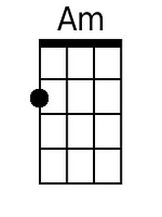 |  |  | 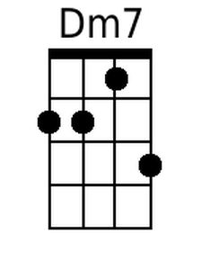
 |  |  |  |  |  |  |  | 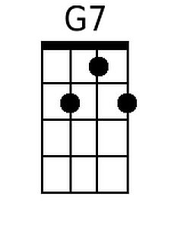 |  |  | 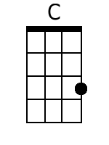
 |  |  |  |  |  |  |  | 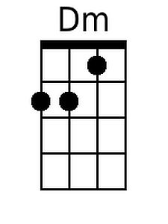 |  |  | 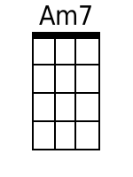
 |  |  |  |  |  |  |  | 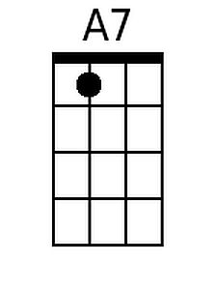 |  |  | 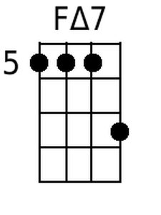
 |  |  |  |  |  |  |  | 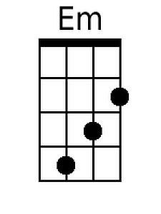
Baritone
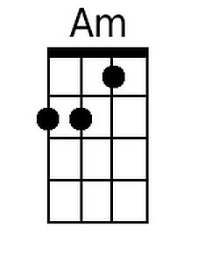 | 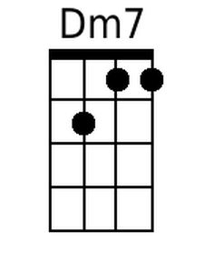 | 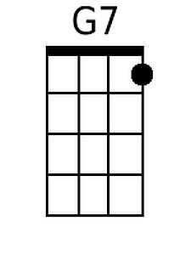 | 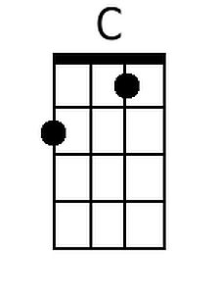 | 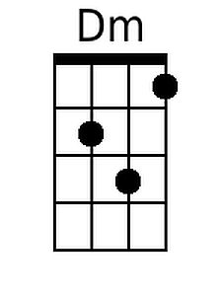 |  | 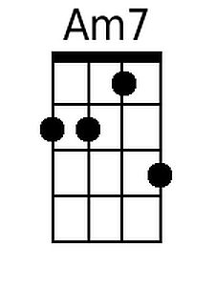 | 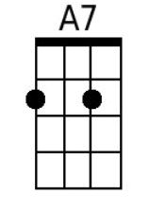 |  | 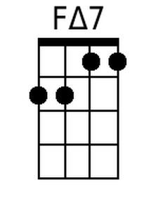 | 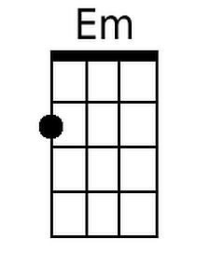

Suicide is Painless (Johnny Mandel and Mike Altman, 1970)
Theme from M.A.S.H. - Key Em

Intro: Em

Am7 D7 G Em
Through early morning fog I see, visions of the things to be
Am D7 G Em7 E7
The pains that are with-held for me, I realize and I can see,

Refrain
Am7 D7 G Em7
That suicide is painless, it brings on many changes
Cmaj7 Bm Am D7 Em Em
And I can take or leave it if I please

Am7 D7 G Em
I try to find a way to make all our little joys relate
Am D7 G Em7 E7
Without that ever present hate. But now I know that it's too late, and, Refrain

Am7 D7 G Em7
The game of life is hard to play, I'm gonna lose it anyway
Am D7 G Em7 E7
The losing card I'll someday lay, so this is all I have to say . Refrain

Am7 D7 G Em7
The only way to win is cheat, and lay it down before I'm beat
Am D7 G Em7 E7
And to another give my seat for that's the only painless feat . Refrain

Am7 D7 G Em7
The sword of time will pierce our skins, it doesn't hurt when it begins
Am D7 G Em7 E7
But as it works its way on in the pain grows stronger watch it grin, Refrain

Am7 D7 G Em7
A brave man once requested me to answer questions that are key
Am D7 G Em7 E7
Is it to be or not to be ? And I replied 'Oh, why ask me? Refrain

Bm Am D7 Em Em
And you can do the same thing, if you please.

 |  |  |  |  |  |  |  |  | 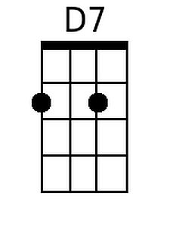 |  | 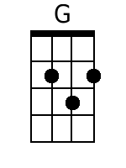
 |  |  |  |  |  |  |  |  |  |  | 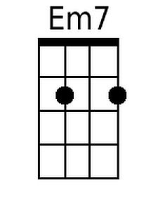
 |  |  |  |  |  |  |  |  | 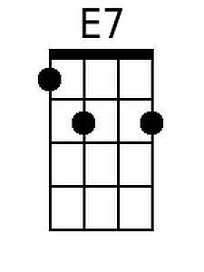 |  | 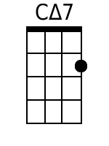
 |  |  |  |  |  |  |  |  | 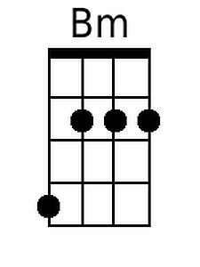
Baritone
 |  | 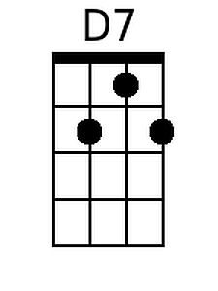 | 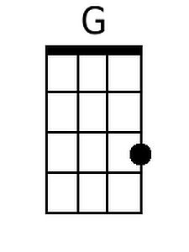 |  |  | 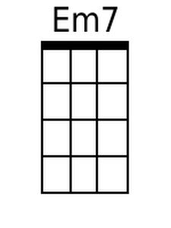 | 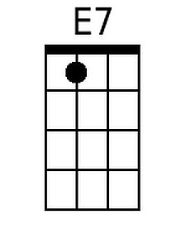 | 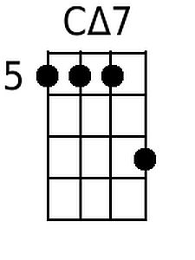 |  |  | 