**Summer Breeze (Seals and Crofts) Key C**

**Intro:** **Am C G Dm / Am C G Am**

**Am C**

See the curtains hanging in the window;

**G D A A7**

in the evening on a Friday night

**Am C**

A little light a shining through the window;

**G D A A7**

Lets me know everything is all right

**Chorus:**

**Dm Em**

Summer breeze, makes me feel fine;

**F C**

Blowing through the jasmine in my mind

**Dm Em**

Summer breeze, makes me feel fine;

**F C**

Blowing through the jasmine in my mind

**(Intro)**

**Am C**

See the paper laying on the sidewalk;

**G D A A7**

A little music from the house next door

**Am C**

So I walk on up to the doorstep;

**G D A A7**

Through the screen and across the floor

**BARITONE**

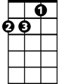

Am

**(Chorus)**

**Am C**

Sweet days of summer,

**G Dm**

The jasmine’s in bloom;

**Am C G Am**

July is dressed up and playing her tune.

**Dm Em**

And I come home from a hard day’s work,

**Dm**

And you're waiting there

**Em E7**

Not a care in the world

**Am C**

See the smile waiting in the kitchen;

**G D A A7**

Food cooking and plates for two

**Am C**

Feel the arms that reach out to hold me;

**G D A A7**

In the evening when the day is through

**(Chorus)**

**Intro (2x)**

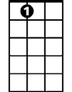

A7

Em

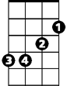

F



Dm



G



C

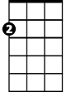

Am

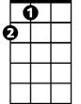

A

E7

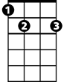

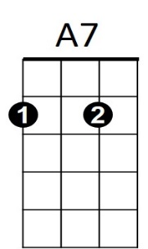



E7



F

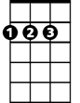

A

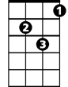

Dm



G

C



Em