Summer Rain (James Richard Hendricks, 1967) (Am)
Summer Rain by Johnny Rivers (Am @ 118)

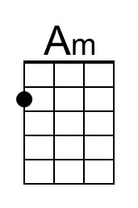 | 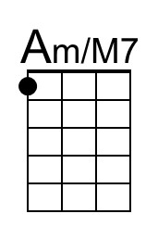 | 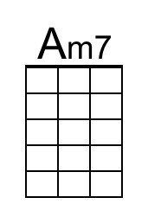 | 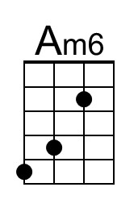 | 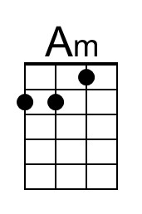 | 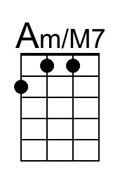 | 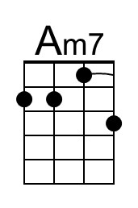 | 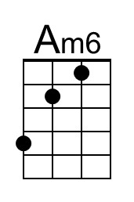

Intro (3x) (Part 1 – 3x then Part 2 )  Am | Am/M7 | Am7 | Am6 | | Intro (Part 2)  F | C | C

Am Am/M7 Am7 Am6 Am Am/M7 Am7 Am6
Summer rain taps at my window, West wind, soft as a sweet dream,
Am Am/M7 Am7 Am6 F C F C | C
My love, warm as the sunshine, _ Sittin' here by me, _ she's here by me.

Am Am/M7 Am7 Am6 Am Am/M7 Am7 Am6
She stepped out of a rainbow, Golden hair, shining like moonglow,
Am Am/M7 Am7 Am6 F C F C | C
Warm lips, soft as her soul, _ Sittin' here by me, yeah, _ she's here by me

Chorus
E7 Am
All summer long, we spent dancin' in the sand
D7
And the jukebox kept on playin'
F G7 | G7
Sergeant Pepper's Lonely Hearts Club Band

Am Am/M7 Am7 Am6 Am Am/M7 Am7 Am6
We sailed into the sunset, Drifted home caught by a Gulf Stream,
Am Am/M7 Am7 Am6
Never gave a thought for to-morrow,
F C F C | C
_ Just let tomorrow be, now, _ let tomorrow be.

Instrumental (3x) (Part 1)  Am | Am/M7 | Am7 | Am6 | | Instrumental (Part 2)  F | C | C

Am Am/M7 Am7 Am6 Am Am/M7 Am7 Am6
She wants to live in the Rockies, She says, that's where we'll find peace
Am Am/M7 Am7 Am6 F C F C | C
Settle down, raise up a family, _ To call our own, yeah, _ we'll have a home.

Summer Rain (Am) – Page 2

Chorus
E7 Am
All summer long, we spent dancin' in the sand.
D7
And everybody kept on playin'
F | F | G7
Sergeant Pepper's Lonely Hearts Club Band.

Am Am/M7 Am7 Am6 Am Am/M7 Am7 Am6
Winter snow drifts by my window , North wind blowin' like thunder
Am Am/M7 Am7 Am6 F C
Our love's burnin' like fire, _ And she's here by me, yeah,
F C F C | C
_ She's here with me, _ Let tomorrow be.

Outro (3x)
Am | Am/M7 | Am7 | Am6 |

Summer Rain (James Richard Hendricks, 1967) (Em)
Summer Rain by Johnny Rivers (Am @ 118)

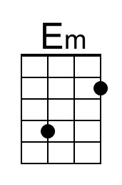 | 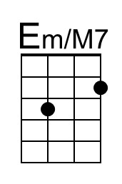 | 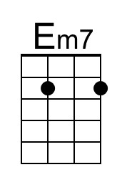 | 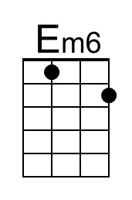 | 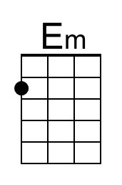 | 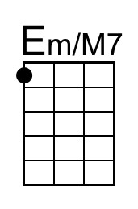 | 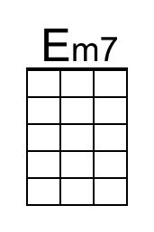 | 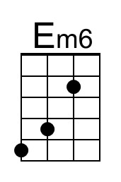

Intro (3x) (Part 1 – 3x then Part 2 )  Em | Em/M7 | Em7 | Em6 | | Intro (Part 2)  C | G | G

Em Em/M7 Em7 Em6 Em Em/M7 Em7 Em6
Summer rain taps at my window, West wind, soft as a sweet dream,
Em Em/M7 Em7 Em6 C G C G | G
My love, warm as the sunshine, _ Sittin' here by me, _ she's here by me.

Em Em/M7 Em7 Em6 Em Em/M7 Em7 Em6
She stepped out of a rainbow, Golden hair, shining like moonglow,
Em Em/M7 Em7 Em6 C G C G | G
Warm lips, soft as her soul, _ Sittin' here by me, yeah, _ she's here by me

Chorus
B7 Em
All summer long, we spent dancin' in the sand
A7
And the jukebox kept on playin'
C D7 | D7
Sergeant Pepper's Lonely Hearts Club Band

Em Em/M7 Em7 Em6 Em Em/M7 Em7 Em6
We sailed into the sunset, Drifted home caught by a Gulf Stream,
Em Em/M7 Em7 Em6
Never gave a thought for to-morrow,
C G C G | G
_ Just let tomorrow be, now, _ let tomorrow be.

Instrumental (3x) (Part 1)  Em | Em/M7 | Em7 | Em6 | | Instrumental (Part 2)  C | G | G

Em Em/M7 Em7 Em6 Em Em/M7 Em7 Em6
She wants to live in the Rockies, She says, that's where we'll find peace
Em Em/M7 Em7 Em6 C G C G | G
Settle down, raise up a family, _ To call our own, yeah, _ we'll have a home.

Summer Rain (Em) – Page 2

Chorus
B7 Em
All summer long, we spent dancin' in the sand.
A7
And everybody kept on playin'
C | C | D7
Sergeant Pepper's Lonely Hearts Club Band.

Em Em/M7 Em7 Em6 Em Em/M7 Em7 Em6
Winter snow drifts by my window , North wind blowin' like thunder
Em Em/M7 Em7 Em6 C G
Our love's burnin' like fire, _ And she's here by me, yeah,
C G C G | G
_ She's here with me, _ Let tomorrow be.

Outro (3x)
Em | Em/M7 | Em7 | Em6 |

