**Summer in the City (Mark Sebastian)**

**Dm G 3x**

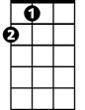

A

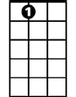

A7

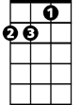

Dm



G

**Dm G**

Hot town, summer in the city

**Dm G**

Back of my neck gettin' dirty-'n'-gritty

**Dm G**

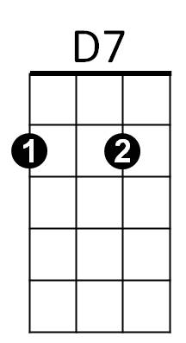Been down, isn't it a pity



C

Em

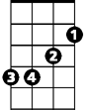

**Dm G**

Doesn't seem to be a shadow in the city

**A A7**

All around people lookin' half dead

**Dm D7**

Walking on the sidewalk, hotter than a match-head

**Chorus:**

**G C**

But at night it's a different world

**G C**

Go out and find a girl

**G C**

Come on, come on and dance all night

**G C**

Despite the heat, it'll be all right

**Em A**

And babe, don't you know it's a pity

**Em A**

That the days can't be like the nights

**Em A**

In the summer in the city

**Em A**

In the summer in the city

**Dm G**

**BARITONE**

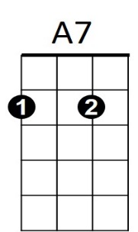Cool town, evening in the city

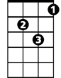

Dm



G

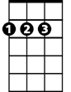

A

**Dm G**

Dressed so fine and looking so pretty

**Dm G**

Cool cat, looking for a kitty

**Dm G**

Gonna look in every corner of the city

**A A7**

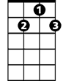

D7

C

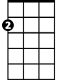

Em

'Til I'm wheezing like a bus stop

**Dm D7**

Runnin' up the stairs, gonna meet you on the roof top

**(Chorus)**

**{Repeat first verse}**

**(Chorus) End in Dm**