**Summertime, Summertime (Tom Jameson, 1958)**

[**Summertime, Summertime by the Jamies**](https://www.youtube.com/watch?v=TK_z73tVbgU) **(1958, 1962) – Key of C**

**Starting Notes: G to C**



C

**Intro:**

**(Tacet)**

It's summertime, summertime,

sum, sum, summertime.

**C Am**

Summertime, summertime,

**Dm G7**

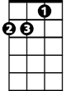

Dm

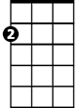

Am

Sum, sum, summertime.

**C F**

Summertime, summertime,

**Dm G7**

Sum, sum, summertime

**C F**

Summertime, summertime,

**Dm G7 C F C**

Sum, su m, summertime, summertime...

**C G Dm G7**

Well, shut them books and throw 'em a-way

F



**C G Dm G7**

And say good-bye to dull school days

**C G Dm G7**

Look a-live and change your ways

**C F C**

It's summertime...

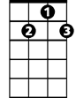

G7

**C F**

Well, no more studying - history

**G C**

And no more reading ge - ography

**F G7**

And no more dull ge - ometry

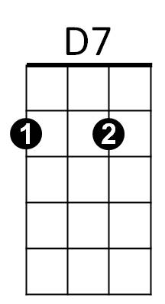 **C D7 G D7 G**

Be-cause it's sum - mer-time

**Chorus**

**NC G7 C**

It's time to head straight for them hills

**G7 C**



G

It's time to live and have some thrills

**F C**

Come a-long and have a ball

**G D7 G**

A reg-u-lar free-for-all

**C G Dm G7**

Well are you comin' or are you ain't

**BARITONE**

**C G Dm G7**

C



You slow pokes are my one com-plaint

**C G Dm G7**

Hurry up be-fore I faint

**C F C**

It's summertime



Am

**C F**

Well, I'm so happy that - I could flip

**G C**

Oh, how I'd love to - take a trip

**F G7**

I'm sorry teacher but - zip your lip

**C D7 G D7 G**

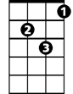

Dm

Be-cause it's sum - mer-time. **Chorus**

**C G Dm G7**

Well, we'll go swimmin' every day

**C G Dm G7**

No time to work just time to play

**C G Dm G7**



F

If your folks com-plain just say,

**C F C**

"It's summertime"

**C F**

And ev'ry night we'll - have a dance

**G C**

Cause what's a vacation with - out romance

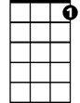

G7

**F G7**

Oh man, this jive gets me - in a trance

**C D7 G D7 G**

Be-cause it's sum - mer-time. **Chorus**

**C F**

It's summertime.



D7



G

**Repeat Intro**

**Outro:**

**F C NC**

It's summertime.

**Summertime, Summertime (Tom Jameson, 1958)**

[**Summertime, Summertime by the Jamies**](https://www.youtube.com/watch?v=TK_z73tVbgU) **(1958, 1962) – Key of G**

**Starting Notes: D to G**



G

**BARITONE**

**Intro**

**(Tacet)**

It's summertime, summertime,

sum, sum, summertime.

**G Em**

Summertime, summertime,

**Am D7**



Am

Em

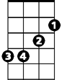

Sum, sum, summertime.

**G C**

Summertime, summertime,

**Am D7**

Sum, sum, summertime.

**G C**

Summertime, summertime,

**Am D7 G C G**

Sum, sum, summertime, summertime...

**G D Am D7**

Well, shut them books and throw 'em a-way

 **G D Am D7**

And say good-bye to dull school days

**G D Am D7**

Look a-live and change your ways

**G C G**

It's summertime...

**G C**



C

Well, no more studying - history

**D G**

And no more reading ge - ography

**C D7**

And no more dull ge - ometry

**G A7 D A7 D**

Be-cause it's sum - mer-time

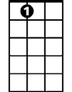

A7

**Chorus**

**NC D7 G**

It's time to head straight for them hills

**D7 G**

It's time to live and have some thrills

**C G**

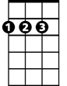

D

Come a-long and have a ball

**D A7 D**

A reg-u-lar free-for-all

**G D Am D7**

Well, are you comin' or are you ain't



G

**G D Am D7**

You slow pokes are my one com-plaint

**G D Am D7**

Hurry up be-fore I faint

**G C G**

It's summertime...



Em

**C F**

Well, I'm so happy that - I could flip

**D G**

Oh, how I'd love to - take a trip

**C D7**

I'm sorry teacher but - zip your lip

**G A7 D A7 D**

Be-cause it's sum – mer-time. **Chorus**



Am

**G D Am D7**

Well, we'll go swimmin' every day

**G D Am D7**

No time to work just time to play

**G D Am D7**



D7

If your folks com-plain just say,

**G C G**

It's summertime...

**G C**

And ev'ry night we'll - have a dance

**D G**

Cause what's a vacation with - out romance

C



**C D7**

Oh man, this jive gets me - in a trance

**G A7 D A7 D**

Be-cause it's sum - mer-time. **Chorus**

**G C**

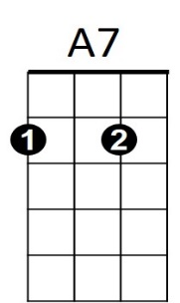It's summertime.

**Repeat Intro**

**C G NC**

**Outro:** It's summertime.



D