**Summertime (Gershwin Ira / Gershwin George / Heyward Du Bose)**

**Intro: Dm** **Am 4x**

**Am** **Dm** **Am** **Dm** **Am** **Dm** **Am**

Summertime, and the livin' is easy

**Dm** **E7** **C7**  **E7**

Fish are jumpin' and the cotton is high

**Am** **Dm** **Am** **Dm** **Am** **Dm** **Am**

Your daddy's rich, and your momma's good lookin'

**C** **D7** **E7** **Am** **Dm** **Am**

So hush little baby, don't you cry

**Am** **Dm** **Am** **Dm** **Am** **Dm** **Am**

One of these mornings, you're gonna rise up singing

**D**  **m** **E7** **C7** **E7**

Then you'll spread your wings, and you'll take to the sky

**Am** **Dm** **Am** **Dm** **Am** **Dm** **Am**

But till that morning, there's a n othin' can harm you

**C** **D7** **E7** **Am** **Dm** **Am**

With daddy and mammy, standing by

**Am** **Dm** **Am** **Dm** **Am** **Dm** **Am**

Summertime, and the livin' is easy

**Dm** **E7** **C7**  **E7**

Fish are jumpin' and the cotton is high

**Am** **Dm** **Am** **Dm** **Am** **Dm** **Am**

Your daddy's rich, and your momma's good lookin'

**C** **D7** **E7** **Am** **Dm** **Am**

So hush little baby, don't you cry

**C** **D7** **E7** **Am** **Dm** **Am**

So hush little baby, don't you cry

**BARITONE**

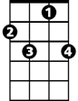

C7

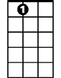

E7

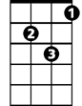

Dm

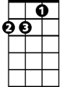

Am

C



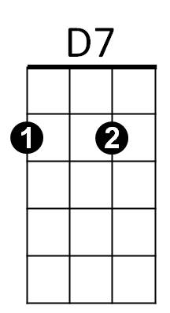

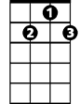

D7

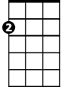

Am

E7

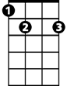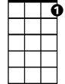

C7



C



Dm