**Sundown (Gordon Lightfoot) Key A**

**Intro: A A7**

**A**

I can see her lyin' back in her satin dress

**E7 A**

In a room where you do what you don't confess

**D**

Sundown you better take care

**G A**

If I find you've been creepin' 'round my back stairs

**D**

Sundown you better take care

**G A**

If I find you've been creepin' 'round my back stairs

**A**

She's been lookin' like a queen in a sailor's dream

**E7 A**

And she don't always say what she really means

**D**

Sometimes I think it's a shame

**G A**

When I get feelin' better when I'm feelin' no pain

**D**

Sometimes I think it's a shame

**G A**

When I get feelin' better when I'm feelin' no pain

**A**

I can picture every move that a man could make

**E7 A**

Getting lost in her lovin' is your first mistake

**D**

Sundown you better take care

**G A**

If I find you've been creepin' 'round my back stairs

**D**

Sometimes I think it's a sin

**G A**

When I feel like I'm winnin' when I'm losin’ again

**A**

I can see her lookin' fast in her faded jeans

**E7 A**

She's a hard lovin' woman, got me feelin' mean

**D**

Sometimes I think it's a shame

**G A**

When I get feelin' better when I'm feelin' no pain

**D**

Sundown you better take care

**G A**

If I find you've been creepin' 'round my back stairs

**D**

Sundown you better take care

**G A**

If I find you've been creepin' 'round my back stairs

**D**

Sometimes I think it's a sin

**G A**

When I feel like I'm winnin' when I'm losin' again

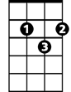

G

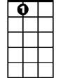

A7

E7

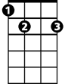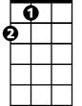

A

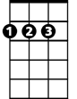

D

**BARITONE**

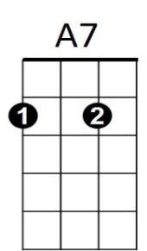



A



E7



D

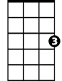

G

**Sundown (Gordon Lightfoot) Key C**

**Intro: C C7**

**C**

I can see her lyin' back in her satin dress

**G7 C**

In a room where you do what you don't confess

**F**

Sundown you better take care

**Bb C**

If I find you've been creepin' 'round my back stairs

**F**

Sundown you better take care

**Bb C**

If I find you've been creepin' 'round my back stairs

**C**

She's been lookin' like a queen in a sailor's dream

**G7 C**

And she don't always say what she really means

**F**

Sometimes I think it's a shame

**Bb C**

When I get feelin' better when I'm feelin' no pain

**F**

Sometimes I think it's a shame

**Bb C**

When I get feelin' better when I'm feelin' no pain

**C**

I can picture every move that a man could make

**G7 C**

Getting lost in her lovin' is your first mistake

**F**

Sundown you better take care

**Bb C**

If I find you've been creepin' 'round my back stairs

**F**

Sometimes I think it's a sin

**Bb C**

When I feel like I'm winnin' when I'm losin’ again

**C**

I can see her lookin' fast in her faded jeans

**G7 C**

She's a hard lovin' woman, got me feelin' mean

**F**

Sometimes I think it's a shame

**Bb C**

When I get feelin' better when I'm feelin' no pain

**F**

Sundown you better take care

**Bb C**

If I find you've been creepin' 'round my back stairs

**F**

Sundown you better take care

**Bb C**

If I find you've been creepin' 'round my back stairs

**F**

Sometimes I think it's a sin

**Bb C**

When I feel like I'm winnin' when I'm losin' again

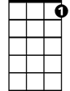

C7



C

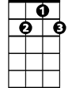

G7

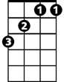

Bb

F

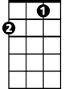

**BARITONE**

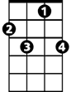

C7



G7



F

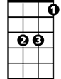

Bb

C



**Sundown (Gordon Lightfoot) Key G**

**Intro: G G7**

**G**

I can see her lyin' back in her satin dress

**D7 G**

In a room where you do what you don't confess

**C**

Sundown you better take care

**F G**

If I find you've been creepin' 'round my back stairs

**C**

Sundown you better take care

**F G**

If I find you've been creepin' 'round my back stairs

**G**

She's been lookin' like a queen in a sailor's dream

**D7 G**

And she don't always say what she really means

**C**

Sometimes I think it's a shame

**F G**

When I get feelin' better when I'm feelin' no pain

**C**

Sometimes I think it's a shame

**F G**

When I get feelin' better when I'm feelin' no pain

**G**

I can picture every move that a man could make

**D7 G**

Getting lost in her lovin' is your first mistake

**C**

Sundown you better take care

**F G**

If I find you've been creepin' 'round my back stairs

**C**

Sometimes I think it's a sin

**F G**

When I feel like I'm winnin' when I'm losin’ again

**G**

I can see her lookin' fast in her faded jeans

**D7 G**

She's a hard lovin' woman, got me feelin' mean

**C**

Sometimes I think it's a shame

**F G**

When I get feelin' better when I'm feelin' no pain

**C**

Sundown you better take care

**F G**

If I find you've been creepin' 'round my back stairs

**C**

Sundown you better take care

**F G**

If I find you've been creepin' 'round my back stairs

**C**

Sometimes I think it's a sin

**F G**

When I feel like I'm winnin' when I'm losin' again

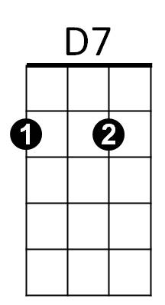



G



G7

F



C

**BARITONE**



G7

C



F



D7



G