**Sunny Afternoon (The Kinks)**

**Intro: Am G F E7**

**Am G**

The taxman’s taken all my dough,

**C G**

And left me in my stately home.

**E7 Am**

Lazing on a sunny afternoon

**G**

And I can't sail my yacht,

**C G**

She’s taken everything I've got.

**E7 Am E7**

Lazing on a sunny afternoon.

**A7 D7**

Save me, save me, save me from this squeeze,

**G G7 C E7**

I got a big fat momma trying to break me.

**Am D7**

Because I love to live so pleasantly,

**Am D7**

In this life of luxury.

**C E7 Am**

Lazing on a sunny afternoon.

**E7 Am E7**

In the summer time, in the summer time.

**Am E7 Am E7**

In the summer time, in the summer time

**Am G**

My girlfriend’s run off with my car

**C G**

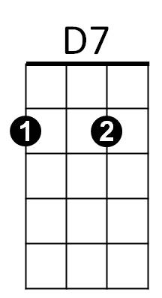And gone back to her ma and pa's

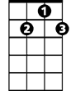

G7



G

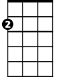

Am

F



E7

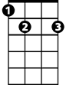

C

**E7 Am**

Telling tales of drunkenness and cruelty.

**G**

And now I'm sitting here,

**C G**

I'm sipping on my ice cold beer.

**E7 Am E7**

Lazing on a sunny afternoon.

**BARITONE**



F



G

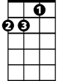

Am

C

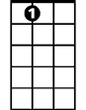

E7



D7

**A7 D7**

Help me, help me, help me sail away,

**G G7 C E7**

Ah, give me two good reasons why I ought to stay.

**Am D7**

Because I love to live so pleasantly,

**Am D7**

In this life of luxury.

**C E7 Am**

Lazing on a sunny afternoon.

**E7 Am E7**

In the summer time, in the summer time.

**Am E7 Am E7**

In the summer time, in the summer time

.

**A7 D7**

Save me, save me, save me from this squeeze,

**G G7 C E7**

I got a big fat momma trying to break me.

**Am D7**

Because I love to live so pleasantly,

**Am D7**

In this life of luxury.

**C E7 Am**

Lazing on a sunny afternoon.

**E7 Am E7**

In the summer time, in the summer time.

**Am E7 Am E7**

In the summer time, in the summer time

**Repeat last line to fade**

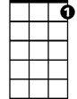

G7