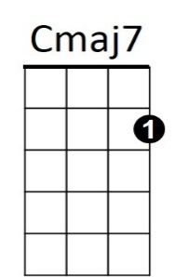 **Sunny Skies (James Taylor)**

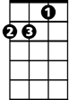

Dm



C

**Cmaj7 Dm Cmaj7 Dm**

Sunny Skies sleeps in the morning, he doesn't know when to rise

**Cmaj7 Dm Cmaj7**

He closes his weary eyes upon the day

**Dm Cmaj7 Dm Cmaj7**

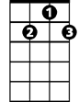

G7

Look at him yawning, throwing his morning hours away

**Cmaj7 Dm G7 Cmaj7 Dm C**

He knows how to ease down slowly, everything is fine in the end

**Dm G7 Cmaj7 Dm G7**

And you will be pleased to know that Sunny Skies hasn't a friend

**Cmaj7 Dm Cmaj7 Dm**

Sunny Skies weeps in the ev'nin', it doesn't much matter why

**Cmaj7 Dm Cmaj7**

I guess he just has to cry from time to time

**Dm Cmaj7 Dm Cmaj7**

Everyone's leavin', and Sunny Skies has to stay behind

**Cmaj7 Dm G7 Cmaj7 Dm C**

Still he knows how to ease down slow(ly), everything is fine in the end.

**Dm G7 Cmaj7 Dm G7**

And you will be pleased to know that Sunny Skies hasn't a friend

**BARITONE**

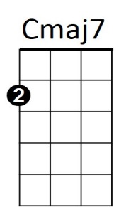

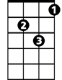

Dm

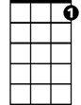

G7

C



**Cmaj7 Dm Cmaj7 Dm**

Sunny Skies sleeps in the morning, he doesn't know when to rise

**Cmaj7 Dm Cmaj7**

He closes his weary eyes upon the day

**Dm Cmaj7 Dm Cmaj7**

And throws it all away.

**Dm G7 Cmaj7 Dm Cmaj7**

Looking at the snow and trees that grow outside my window

**Dm G7 Cmaj7 Dm Cmaj7**

Looking at the things that pass me by.

**Dm G7 Cmaj7 Dm Cmaj7 Dm Cmaj7**

Wondering if where I've been is worth the things I've been through

**Dm G7 Cmaj7**

Ending with a friend named Sunny Skies.