**Sunny (Bobby Hebb, 1966)**

**Am C7 F E7**

Sunny.. ..yesterday my life was filled with rain.



C

E7

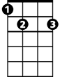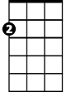

Am

F

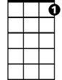

C7

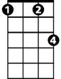

Fm

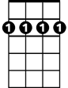

Bm7

**Am C7 F E7**

Sunny.. ..you smiled at me and really eased the pain.

**Am C**

Oh, the dark days are done and the bright days are here,

**F Fm**

My sunny one shines so sincere.

**Bm7 E7 Am E7**

Oh, Sunny one so true, I love you.

**Am C7 F E7**

Sunny, thank you for the sunshine bouquet.

**Am C7 F E7**

Sunny, thank you for the love you brought my way.

**Am C**

You gave to me your all and all,

**F Fm**

Now I feel ten feet tall.

**Bm7 E7 Am E7**

Oh, Sunny one so true, I love you.

**Am C7 F E7**

Sunny.. . .thank you for the truth you've let me see.

**Am C7 F E7**

**BARITONE**

Sunny.. ..thank you for the facts from A to Z.

**Am C**

Bm7

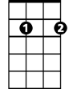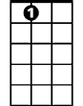

E7



F

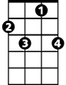

C7

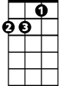

Am

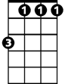

Fm

C



My life was torn like wind blown sand,

**F Fm**

Then a rock was formed when we held hands.

**Bm7 E7 Am E7**

Sunny one so true, I love you.

**Am C7 F E7**

Sunny, thank you for that smile upon your face.

**Am C7 F E7**

Sunny, thank you for that gleam that flows with grace.

**Am C**

You're my spark of nature's fire,

**F Fm**

You're my sweet complete desire.

**Bm7 E7 Am**

Sunny one so true, I love you.

**Bm7 E7 Am**

Sunny one so true, I love you.

**Sunny (Bobby Hebb, 1966)**

**Dm F7 Bb A7**



Bb



F7



Dm

Sunny.. ..yesterday my life was filled with rain.

**Dm F7 Bb A7**

Sunny.. ..you smiled at me and really eased the pain.

**Dm F**

Oh, the dark days are done and the bright days are here,

**Bb Bbm**

My sunny one shines so sincere.



Bbm

F



A7

**Em7 A7 Dm A7**

Oh, Sunny one so true, I love you.

**Dm F7 Bb A7**

Sunny, thank you for the sunshine bouquet.

**Dm F7 Bb A7**

Em7



Sunny, thank you for the love you brought my way.

**Dm F**

You gave to me your all and all,

**Bb Bbm**

Now I feel ten feet tall.

**Em7 A7 Dm A7**

Oh, Sunny one so true, I love you.

**Dm F7 Bb A7**

Sunny.. . .thank you for the truth you've let me see.

**BARITONE**

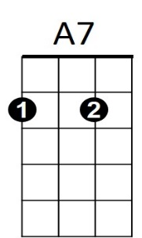**Dm F7 Bb A7**

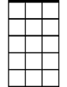

Em7

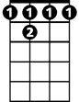

F7

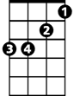

Bbm



F

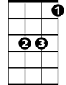

Bb

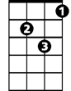

Dm

Sunny.. ..thank you for the facts from A to Z.

**Dm F**

My life was torn like wind blown sand,

**Bb Bbm**

Then a rock was formed when we held hands.

**Em7 A7 Dm A7**

Sunny one so true, I love you.

**Dm F7 Bb A7**

Sunny, thank you for that smile upon your face.

**Dm F7 Bb A7**

Sunny, thank you for that gleam that flows with grace.

**Dm F**

You're my spark of nature's fire,

**Bb Bbm**

You're my sweet complete desire.

**Em7 A7 Dm**

Sunny one so true, I love you.

**Em7 A7 Dm**

Sunny one so true, I love you.