**Sunrise, Sunset (Jerry Bock / Sheldon Harnick) Key Am**

**Am E7 Am E7**

Is this the little girl I car - ried?

**Am E7 Am A7**

Is this the little boy at play?

**Dm A7 Dm**

I don't remember growing older –

**B B7 E7**

When did they?

**Am E7 Am E7**

When did she get to be a beau - ty?

**Am E7**  **Am A7**

When did he grow to be so tall?

**Dm A7 Dm B7 E7**

Wasn't it yesterday when they were small?

**E7 E7+5 E7**

**Chorus:**

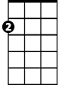

Am

E7

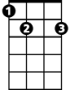

**Am Dm Am E7**

Sun-rise, sun-set,

**Am Dm Am E7**

Sun- rise, sun- set,

**Am Dm Am Dm Am A7**

Swift - ly flow the days;

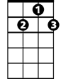

G7

**Dm G7 C Am**

Seedlings turn overnight to sun - flow'rs,

**Bm7 E7 Am**

Blossoming even as we gaze.

**E7 E7+5 E7**

**Am Dm Am E7**

Sun-rise, sun-set,

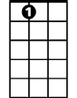

E7

**Am Dm Am E7**

Sun- rise, sun- set,

**Am Dm Am Dm Am A7**

Swift-ly fly the years;

**Dm G7 C Am**

One season following anoth - er,

**Dm E7 E7+5 Am**

Bm7

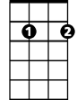

Laden with hap-pi-ness...and tears.

**Am E7 Am E7**

What words of wisdom can I give them,

**Am E7 Am A7**

How can I help to ease their way?

**Dm A7 Dm**

Now they must learn from one another,

**B B7 E7**

Day by day.

**Am E7 Am E7**

They look so natural to-geth - er.

**Am E7 Am A7**

Just like two newlyweds should be.

**Dm A7 Dm B7 E7**

Is there a canopy in store for me?

**(Chorus) (Extend last line) End with C6**

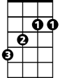

B

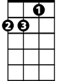

Dm



A7

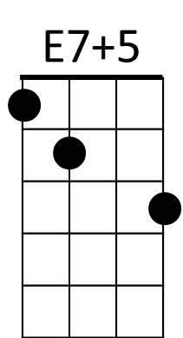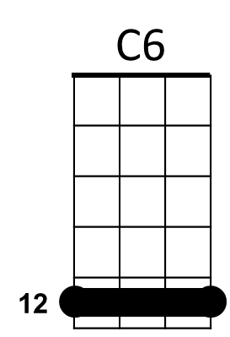

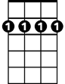

Bm7



C

**BARITONE**

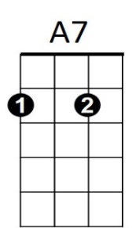

B

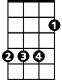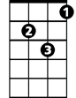

Dm



Am

B7



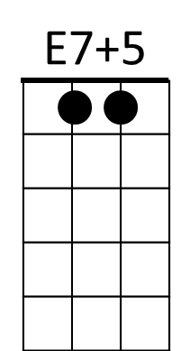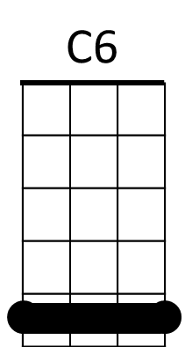

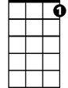

G7

C



**Sunrise, Sunset (Jerry Bock / Sheldon Harnick) Key Dm**

**Dm A7 Dm A7**

Is this the little girl I car - ried?

**Dm A7 Dm D7**

Is this the little boy at play?

**Gm D7 Gm**

I don't remember growing older –

**Em7 E7 A7**

When did they?

**Dm A7 Dm A7**

When did she get to be a beau - ty?

**Dm A7**  **Dm D7**

When did he grow to be so tall?

**Gm D7 Gm E7 A7**

Wasn't it yesterday when they were small?

**A7 A7+5 A7**



Dm

**Chorus:**

**Dm Gm Dm A7**

Sun-rise, sun-set,

**Dm Gm Dm A7**

Sun- rise, sun- set,

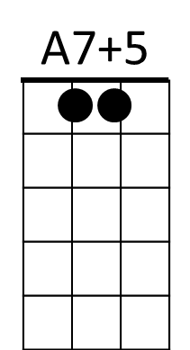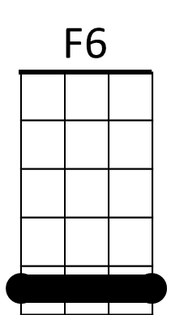**Dm Gm Dm Gm Dm D7**

E7



Swift - ly flow the days;

**Gm C7 F Dm**

Seedlings turn overnight to sun - flow'rs,

**Em7 A7 Dm**

Blossoming even as we gaze.

**Dm Gm Dm A7**

**BARITONE**

Sun-rise, sun-set,

**Dm Gm Dm A7**

Sun- rise, sun- set,

**Dm Gm Dm Gm Dm D7**

Swift-ly fly the years;

**Gm C7 F Dm**

One season following anoth - er,

**Gm A7 A7+5 Dm**



E7

Laden with hap-pi-ness..and tears.



**Dm A7 Dm A7**

What words of wisdom can I give them,

**Dm A7 Dm D7**

How can I help to ease their way?

**Gm D7 Gm**

Now they must learn from one another,

**Em7 E7 A7**

Day by day.

**Dm A7 Dm A7**

They look so natural to-geth - er.

**Dm A7 Dm D7**

Just like two newlyweds should be.

**Gm D7 Gm E7 A7**

Is there a canopy in store for me?

**(Chorus) (Extend last line) End with F6**

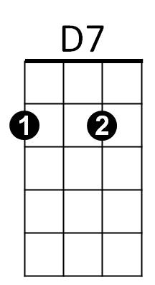



A7



Gm

Em7



C7

F



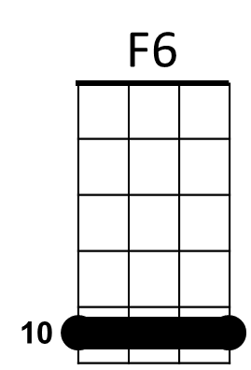****



Dm

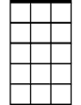

Em7

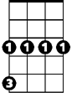

Gm



D7

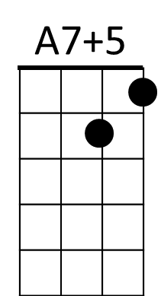



F

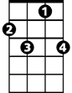

C7