**Sunshine on My Shoulders**

**(John Denver / Michael C Taylor / Richard L Dick Kniss)**

**Intro: C F 4x**

F



**Chorus:**

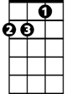

Dm



C

**C F C F C F C F**

Sunshine, on my shoulders, makes me happy.

**C F C F Dm G**

Sunshine, in my eyes, can make me cry

**C F C F C F C F**

Em

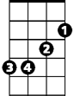

G

Sunshine, on the water, looks so lovely.

**C F C F C F C F**

Sunshine, almost always, make me high

**C Dm Em F C F Em F**

If I had a d ay, that I could give you

**C Dm Em F Dm G**

I'd give to you, a day, just like today.

**C Dm Em F C F Em F**

If I had a song, that I could sing for you.

**C Dm Em F C Dm Em F**

I'd sing a song, to make you feel this way.

**BARITONE**

**(Chorus)**

C

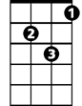

Dm



F

**C Dm Em F C F Em F**

If I had a tale that I could tell you

**C Dm Em F Dm G**

I'd tell a tale sure to make you smile

**C Dm Em F C F Em F**

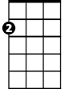

Em



G

If I had a wish that I could wish for you

**C Dm Em F C Dm Em F**

I'd make a wish for sunshine for all the while

**(Chorus)**

**C F C F C F C F**

Sunshine, almost always, make me high

**C F C F C**

Sunshine, almost al - ways