**Surf City (Brian Wilson / Jan Berry)**

**C F G E7**

F



C

Two girls for eve - ry boy

**A**

I bought a '30 Ford wagon

**F#m**

and we call it a woody

**A F#m**

Surf City, here we come



G

**A**

You know it's not very cherry,

**F#m**

It's an oldie but a goodie

**A F#m**

Surf City, here we come

**D Bm**

Well, it ain't got a back seat or a rear window

E7

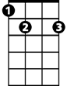

**G E7**

But it still gets me where I wanna go

**Chorus:**

**A**

And we're goin' to Surf City,

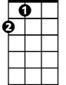

A

'cause it's two to one

You know we're goin' to Surf City,

gonna have some fun

**D**

You know we're goin' to Surf City,

'cause it's two to one

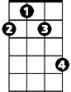

F#m

**A**

You know we're goin' to Surf City,

gonna have some fun, now

**C F G E7**

Two girls for eve - ry boy

**A**

**BARITONE**

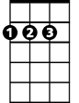

D

They say they never roll the streets up

**F#m**

'Cause there's always somethin' goin'

**A F#m**

Surf City, here we come

**A**

You know they're either out surfin'

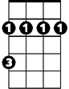

F#m



D

Bm

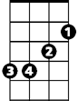

**F#m**

Or they got a party growin'

**A F#m**

Surf City, here we come

**D Bm**

And there's two swingin' honeys for every guy

**G E7**

And all you gotta do is just wink your eye

**(Chorus)**



Bm

**A**

And if my woody breaks down on me

**F#m**

Somewhere on the surf route

**A F#m**

Surf City, here we come



Bb

**A**

I'll strap my board to my back

**F#m**

And hitch a ride in my wetsuit

**A F#m**

Surf City, here we come

**D Bm**

And when I get to Surf City I'll be shootin' the curl

**G E7**

And checkin' out the parties for a surfer girl

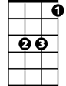

Eb

**A**

And we're goin' to Surf City,

'cause it's two to one

You know we're goin' to Surf City,

gonna have some fun

**D**

You know we're goin' to Surf City,

'cause it's two to one

**A**

You know we're goin' to Surf City,

gonna have some fun, now

**C F Bb Eb G**

Two girls for every - Two girls for every boy

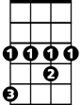

Eb



Bb



A

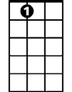

E7

C



F



G