Surfer Girl (Brian Wilson, 1961) (D)
Surfer Girl by The Beach Boys (1963) (D @ 106)
4/4 Time

Intro
D F#m | Bm F#m | G Em | A [ Hold ]
Ooh . . .

D Bm G A Dmaj7 D7 G Gm
Little surfer, little one, Made my heart come all un-done.
D Bm G A D Bm G A
Do you love me? Do you surfer girl? Surfer girl, my little surfer girl.

D Bm G A Dmaj7 D7 G Gm
I have watched you on the shore, standing by the ocean’s roar
D Bm G A D G D - D7
Do you love me? Do you surfer girl? Surfer Girl, Surfer Girl.

Bridge
G A D Bm G A D - D7
We could ride the surf to-geth-er, while our love would grow.
G A D Bm Bm7 E7 A – Bb
In my Woody, I would take you, every-where I go.

Eb Cm Ab Bb Ebmaj7 Eb7 Ab Abm
So I say from me to you, I will make your dreams come true.
Eb Cm Ab Bb Eb Cm Ab Bb
Do you love me? Do you Surfer [Hold] Girl? Surfer Girl, my little Surfer Girl,
Eb Cm Ab Bb Eb Cm Ab Bb – Eb
Girl, Surfer Girl, my little Surfer Girl. Girl, Surfer Girl, my little surfer girl.

Ab Bb | Eb Cm | Ab Bb | Eb Cm | Cm

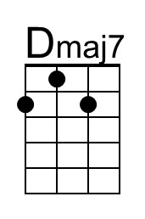 | 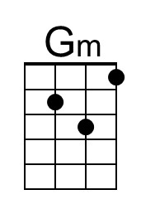 | 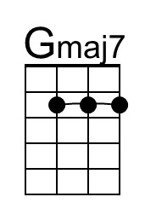 | 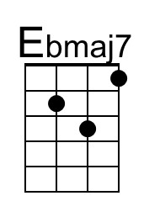 | 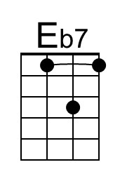 | 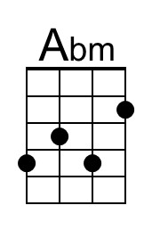 | 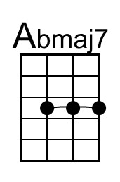
Baritone | 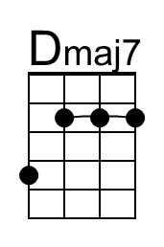 | 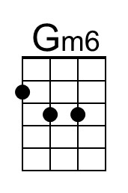 | 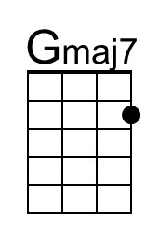 | 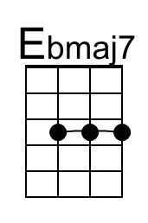 | 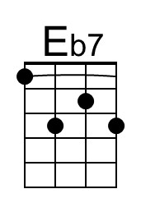 | 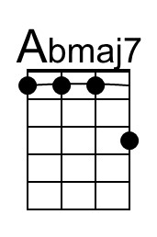

Surfer Girl (Brian Wilson, 1961) (A)
Surfer Girl by The Beach Boys (1963) (D @ 106)
4/4 Time

Intro
A C#m | F#m C#m | D Bm | E [ Hold ]
Ooh . . .

A F#m D E Amaj7 A7 D Dm
Little surfer, little one, Made my heart come all un-done.
A F#m D E A F#m D E
Do you love me? Do you surfer girl? Surfer girl, my little surfer girl.

A F#m D E Amaj7 A7 D Dm
I have watched you on the shore, standing by the ocean’s roar
A F#m D E A D A - A7
Do you love me? Do you surfer girl? Surfer Girl, Surfer Girl.

Bridge
D E A F#m D E A - A7
We could ride the surf to-geth-er, while our love would grow.
D E A F#m F#m7 B7 E – F
In my Woody, I would take you, every-where I go.

Bb Gm Eb F Bbmaj7 Bb7 Eb Ebm
So I say from me to you, I will make your dreams come true.
Bb Gm Eb F Bb Gm Eb F
Do you love me? Do you Surfer [Hold] Girl? Surfer Girl, my little Surfer Girl,
Bb Gm Eb F Bb Gm Eb F – Bb
Girl, Surfer Girl, my little Surfer Girl. Girl, Surfer Girl, my little surfer girl.

Eb F | Bb Gm | Eb F | Bb Gm | Gm

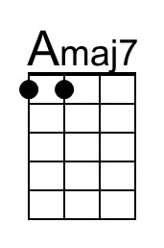 | 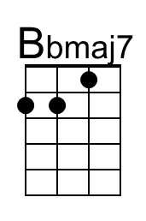 | 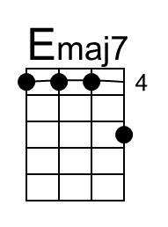
Baritone | 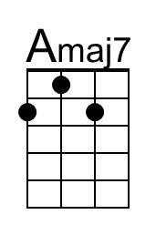 | 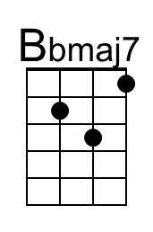 |  |  | 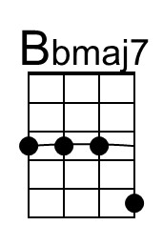

Surfer Girl (Brian Wilson, 1961) (B)
Surfer Girl by The Beach Boys (1963) (D @ 106)
4/4 Time

Intro
B Ebm | Abm Ebm | E C#m | F# [ Hold ]
Ooh . . .

B Abm E F# Bmaj7 B7 E Em
Little surfer, little one, Made my heart come all un-done.
B Abm E F# B Abm E F#
Do you love me? Do you surfer girl? Surfer girl, my little surfer girl.

B Abm E F# Bmaj7 B7 E Em
I have watched you on the shore, standing by the ocean’s roar
B Abm E F# B E B - B7
Do you love me? Do you surfer girl? Surfer Girl, Surfer Girl.

Bridge
E F# B Abm E F# B - B7
We could ride the surf to-geth-er, while our love would grow.
E F# B Abm Abm7 C#7 F# – G
In my Woody, I would take you, every-where I go.

C Am F G Cmaj7 C7 F Fm
So I say from me to you, I will make your dreams come true.
C Am F G C Am F G
Do you love me? Do you Surfer [Hold] Girl? Surfer Girl, my little Surfer Girl,
C Am F G C Am F G – C
Girl, Surfer Girl, my little Surfer Girl. Girl, Surfer Girl, my little surfer girl.

F G | C Am | F G | C Am | Am

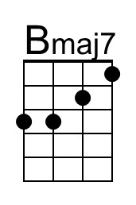 | 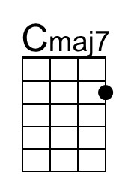 | 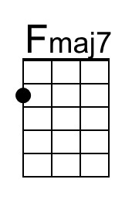
Baritone | 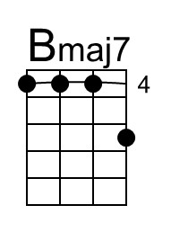 | 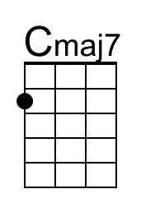 | 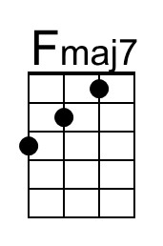

Surfer Girl (Brian Wilson, 1961) (E)
Surfer Girl by The Beach Boys (1963) (D @ 106)
4/4 Time

Intro
E Abm | C#m Abm | A F#m | B [ Hold ]
Ooh . . .

E C#m A B Emaj7 E7 A Am
Little surfer, little one, Made my heart come all un-done.
E C#m A B E C#m A B
Do you love me? Do you surfer girl? Surfer girl, my little surfer girl.

E C#m A B Emaj7 E7 A Am
I have watched you on the shore, standing by the ocean’s roar
E C#m A B E A E - E7
Do you love me? Do you surfer girl? Surfer Girl, Surfer Girl.

Bridge
A B E C#m A B E - E7
We could ride the surf to-geth-er, while our love would grow.
A B E C#m C#m7 F#7 B – C
In my Woody, I would take you, every-where I go.

F Dm Bb C Fmaj7 F7 Bb Bbm
So I say from me to you, I will make your dreams come true.
F Dm Bb C F Dm Bb C
Do you love me? Do you Surfer [Hold] Girl? Surfer Girl, my little Surfer Girl,
F Dm Bb C F Dm Bb C – F
Girl, Surfer Girl, my little Surfer Girl. Girl, Surfer Girl, my little surfer girl.

Bb C | F Dm | Bb C | F Dm | Dm

Baritone | 