**SUSIE Q (Hawkins/Lewis/Broadwater) Key A**

**Intro: (7 measures of A7)**



A7

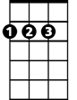

D

E7

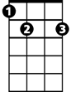

**A7**

Oh Susie Q, oh Susie Q

**D F7 E7 A7**

Oh Susie Q, baby I love you - Susie Q

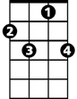

F7

**A7**

I like the way you walk, I like the way you talk

**D F7**

I like the way you walk, I like the way you talk

**E7 A7**

Susie Q

**[Instrumental] (pattern of 2 verses, then 7 measures of A7)**

**A7**

Say that you'll be true, say that you'll be true

**D F7**

Say that you'll be true and never leave me blue

**E7 A7**

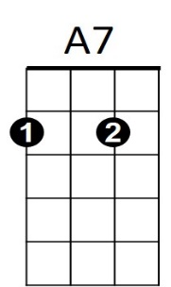Susie Q



D

**BARITONE**

**A7**

Say that you'll be mine, say that you'll be mine

**D F7**

Say that you'll be mine, baby, all the time

**E7 A7**

Susie Q

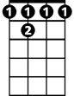

F 7



E7

**[Repeat Verse 1/2]**

**[Repeat Verse 1] (sing 1 octave higher)**

**Outro:**

**A7 (to fade)**

Oh Susie Q