Suzanne (Leonard Cohen) (C)

C  Su-zanne takes you down to her place near the river  Dm  You can hear the boats go by, you can spend the night beside her  C  And you know that she's half-crazy, but that's why you wanna be there  Em F  And she feeds you tea and oranges, that come all the way from China.  C Dm  And just when you mean to tell her, that you have no love to give her,  C Dm  Then she gets you on her wavelength, and she lets the river answer,  C  That you've always been her lover.  Bridge  Em F  And you want to travel with her, and you want to travel blind  C F  And you know that she will trust you, for she's touched your perfect body  C  with her mind.  C  And Jesus was a sailor, when he walked upon the water  Dm  And he spent a long time watching from his lonely wooden tower  C  And when he knew for certain only drowning men could see him, he said,  Em F  'All men will be sailors then, un-til the sea shall free them'  C Dm  But he himself was broken, long be-fore the sky would open  C Dm C  For-saken, almost human, He sank beneath your wisdom like a stone. Bridge.  C  Now Suzanne takes your hand and she leads you to the river.  Dm  She is wearing rags and feathers from Salvation Army counter,  C  And the sun pours down like honey on Our Lady of the Harbor,  Em F  And she shows you where to look a-mong the garbage and the flowers.  C Dm  There are heroes in the seaweed, there are children in the morning  C Dm  They are leaning out for love, and they will lean that way forever,  C  While Suzanne holds the mirror. Bridge. | 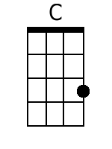  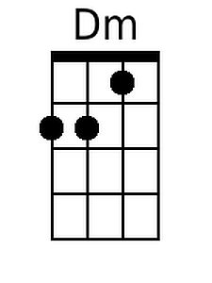  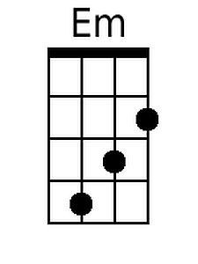  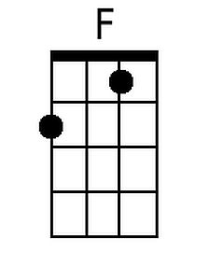
 | Bari
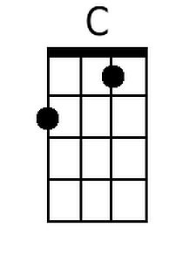
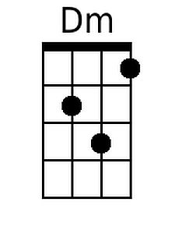
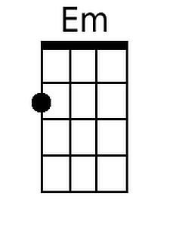
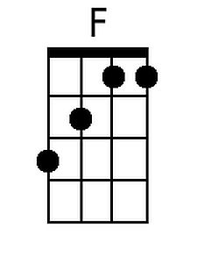

Suzanne (Leonard Cohen) (G)

G  Su-zanne takes you down to her place near the river  Am  You can hear the boats go by, you can spend the night beside her  G  And you know that she's half-crazy, but that's why you wanna be there  Bm C  And she feeds you tea and oranges, that come all the way from China.  G Am  And just when you mean to tell her, that you have no love to give her,  G Am  Then she gets you on her wavelength, and she lets the river answer,  G  That you've always been her lover.  Bridge  Bm C  And you want to travel with her, and you want to travel blind  G C  And you know that she will trust you, for she's touched your perfect body  G  with her mind.  G  And Jesus was a sailor, when he walked upon the water  Am  And he spent a long time watching from his lonely wooden tower  G  And when he knew for certain only drowning men could see him, he said,  Bm C  'All men will be sailors then, un-til the sea shall free them'  G Am  But he himself was broken, long be-fore the sky would open  G Am G  For-saken, almost human, He sank beneath your wisdom like a stone. Bridge.  G  Now Suzanne takes your hand and she leads you to the river.  Am  She is wearing rags and feathers from Salvation Army counter,  G  And the sun pours down like honey on Our Lady of the Harbor,  Bm C  And she shows you where to look a-mong the garbage and the flowers.  G Am  There are heroes in the seaweed, there are children in the morning  G Am  They are leaning out for love, and they will lean that way forever,  G  While Suzanne holds the mirror. Bridge. | 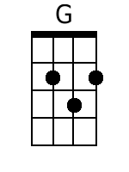  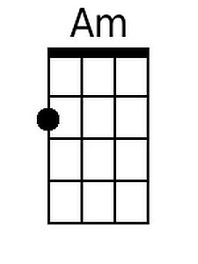  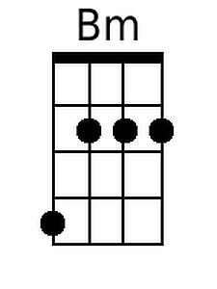
 | Bari
