**Suzanne (Leonard Cohen)**

**C**



C

Suzanne takes you down

To her place near the river

**Dm**

You can hear the boats go by,

You can spend the night beside her

**C**

And you know that she's half-crazy,

F



but that's why you wanna be there

**Em**

And she feeds you tea and oranges

**F**

That come all the way from China

**C**

And just when you mean to tell her

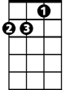

Dm

**Dm**

That you have no love to give her

**C**

Then she gets you on her wavelength

**Dm**

And she lets the river answer

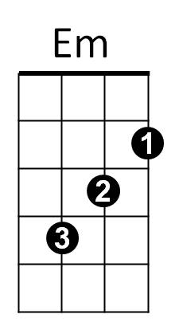 **C**

That you've always been her lover

**Em**

And you want to travel with her,

**F**

And you want to travel blind

**C**

And you know that she will trust you,

**F C**

For you've touched her perfect body with your mind

**C**

And Jesus was a sailor,

when he walked upon the water

**Dm**

And he spent a long time watching

from his lonely wooden tower

**C**

And when he knew for certain only drowning men could see him, he said,

**Em**

'All men will be sailors then,

**F**

**BARITONE**

Until the sea shall free them'

**C**

But he himself was broken,

**Dm**

Long before the sky would open

**C**

Forsaken, almost human,

**Dm C**

He sank beneath your wisdom like a stone

**Em**

And you want to travel with him,

**F**

And you want to travel blind

**C**

And you think maybe you'll trust him,

**F C**

For he's touched your perfect body with his mind

**C**

Now Suzanne takes your hand

and she leads you to the river

**Dm**

She is wearing rags and feathers

from Salvation Army counter

**C**

And the sun pours down like honey

on Our Lady of the Harbor

**Em**

And she shows you where to look

**F**

Among the garbage and the flowers

**C**

There are heroes in the seaweed,

**Dm**

There are children in the morning

**C**

They are leaning out for love,

**Dm**

And they will lean that way forever

**C**

While Suzanne holds the mirror

**Em**

And you want to travel with her,

**F**

and you want to travel blind

**C**

And you know you can trust her,

**F C**

For she's touched your perfect body with her mind

C

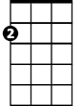

Em

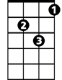

Dm



F