
Sweet City Woman (Rich Dodson, 1971) (C)
Sweet City Woman by The Stampeders (1971)

Intro | C | C | Dm | Dm | Dm | Dm | C | C | (2x)  C Dm | Dm |  Well, I'm on my way, to the city lights.  C | C |  To a pretty face that shines her light on the city nights.  C Dm | Dm |  And I gotta catch a noon train, Gotta be there on time.  C | C |  Oh, it feels so good to know she waits at the end of the line.  Chorus  C Dm | Dm |  Swee-ee-eet, sweet city woman. I can see your face, I can hear your voice,  C | C | Dm | Dm |  I can almost touch you. Swee-ee-eet, sweet city woman  C | C |  Oh, my banjo and me, we got a feel for singin',  Bridge  yeah, yeah,  C F C  Bon c'est bon, bon bon c'est bon, bon. Bon c'est bon, bon, bon, bon, bon  C F C  Bon c'est bon, bon bon c'est bon, bon. Bon c'est bon, bon, bon, bon, bon  F C G C G C  So long ma. So long pa, So - long - Neighbors and friends  C Dm | Dm |  Like a country mornin', all smothered in dew.  C | C |  Ah she's got a way to make a man feel shiny and new  C Dm | Dm |  And she sing in the evenin', oid fa-mil-iar tunes  C | C |  And she feeds me love and tenderness and macaroons. Chorus Only  Outro  C Dm G C | C  Swee-ee-eet, sweet city woman (oh, she's my), Sweet, sweet, sweet, sweet city woman  C Dm G C | C  Swee-ee-eet, sweet city woman (oh, she's my), Sweet, sweet, sweet, sweet city woman  (Everybody)  C Dm | Dm  Sweet, sweet, sweet, sweet city woman (Ba da da da. Ba da da da) (3x)  G C C ˅ ˄ ˅ ˄ ˅ ˅ (Hold)  Sweet, sweet, sweet, sweet city wo - man. | 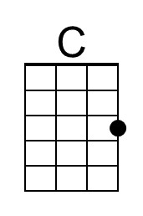
 | 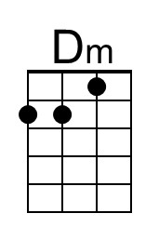
 | 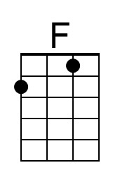
 | 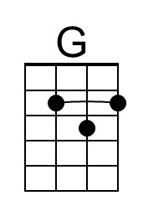
 | 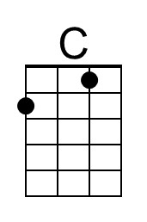
 | 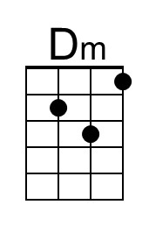
 | 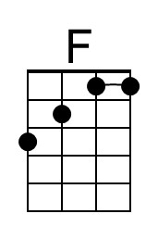
 | 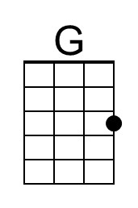

Sweet City Woman (Rich Dodson, 1971) (G) (2/2 Time)
Sweet City Woman by The Stampeders (1971)

Intro (16 Measures) (2x)
G | G | Am | Am | Am | Am | G | G
G Am | Am
1. Well, I'm on my way, to the city lights
Am G | G
To a pretty face that shines her light on the city nights
G Am | Am
And I gotta catch a noon train, Gotta be there on time
Am G | G [Slide]
Oh, it feels so good to know she waits at the end of the line.

Chorus
G Am | Am Am
Swee-ee-eet, sweet city woman. I can see your face, I can hear your voice,
G | G | G Am | Am
I can almost touch you. Swee-ee-eet, sweet city woman
Am G | G
Oh, my banjo and me, we got a feel for singin',

Bridge
(yeah, yeah)
G G C G
Bon, c'est bon _ bon, bon, c'est bon, bon. Bon, c'est bon, bon, bon, bon, bon.
G G C G
Bon, c'est bon _ bon, bon, c'est bon, bon. Bon, c'est bon, bon, bon, bon, bon.
C G D G D G [Slide]
So long ma, so long pa, so long neighbors and friends.

G Am | Am
2. Like a country mornin', all smothered in dew
Am G | G
Ah she's got a way to make a man feel shiny and new.
G Am | Am
And she sing in the evenin', old fam - i - li - ar tunes,
Am G | G [Slide] Chorus
And she feeds me love and tender-ness and macaroons.
 |  |  |  |  |  |  | 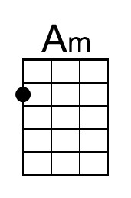
 |  |  |  |  |  |  | 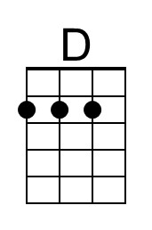
Bari
 | 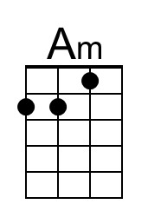 |  | 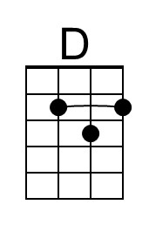 | 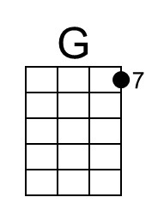 | 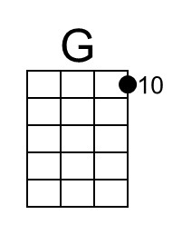 | 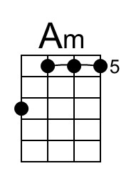 | 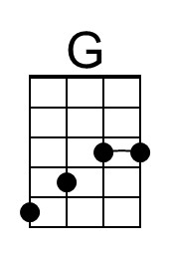

Sweet City Woman (G) – Page 2

Instrumental break – 8 measures
G | G | Am | Am | Am | Am | G | G

Chorus

Outro:
G Am
Daaa da da | da da daaa da da | Da do do do do do do do | oo. _ da da
Am G | G
Da da daaa da da da da | daa da da da da daaa | Do do do do _ do do do | ooo.

G Am | Am Am G | G
Swee-ee-eet, sweet city woman. Oh, she's my sweet, sweet, sweet, sweet city woman.
G Am | Am Am G | G
Swee-ee-eet, sweet city woman. Oh, she's my sweet, sweet, sweet, sweet city woman.

Am G | Am |
Sweet, sweet, sweet, sweet city woman (da da daaa da). 3x Repeat

Am G↓ G↓ (Hold)
Sweet, sweet, sweet, sweet city wo-man.

C-Tuning
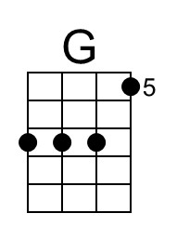 | 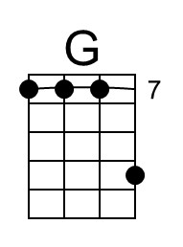 | 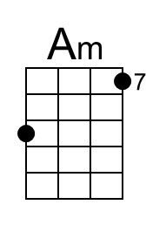 | 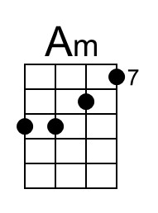
G-Tuning
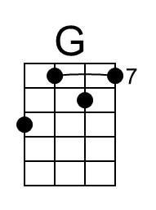 | 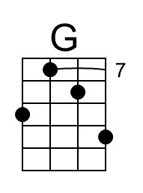 |  | 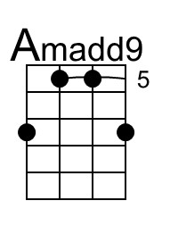 |  | 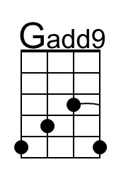
 |  |  | 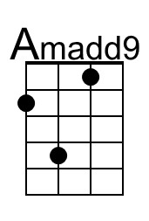 |  | 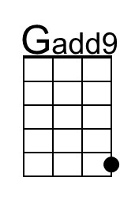

Sweet City Woman (Rich Dodson, 1971) (D)
Sweet City Woman by The Stampeders (1971)

Intro | D | D | Em | Em | Em | Em | D | D | (2x)

D Em | Em |
Well, I'm on my way, to the city lights.
D | D |
To a pretty face that shines her light on the city nights.
D Em | Em |
And I gotta catch a noon train, Gotta be there on time.
D | D |
Oh, it feels so good to know she waits at the end of the line.

Chorus
D Em | Em |
Swee-ee-eet, sweet city woman. I can see your face, I can hear your voice,
D | D | Em | Em |
I can almost touch you. Swee-ee-eet, sweet city woman
D | D |
Oh, my banjo and me, we got a feel for singin',

Bridge
yeah, yeah,
D G D
Bon c'est bon, bon bon c'est bon, bon. Bon c'est bon, bon, bon, bon, bon
D G D
Bon c'est bon, bon bon c'est bon, bon. Bon c'est bon, bon, bon, bon, bon
G D A D A D
So long ma. So long pa, So - long - Neighbors and friends

D Em | Em |
Like a country mornin', all smothered in dew.
E | E |
Ah she's got a way to make a man feel shiny and new
D Em | Em |
And she sing in the evenin', oid fa-mil-iar tunes
D | D |
And she feeds me love and tenderness and macaroons. Chorus Only

Outro
D Em A D | D
Swee-ee-eet, sweet city woman (oh, she's my), Sweet, sweet, sweet, sweet city woman
D Em A D | D
Swee-ee-eet, sweet city woman (oh, she's my), Sweet, sweet, sweet, sweet city woman
(Everybody)
D Em | Em
Sweet, sweet, sweet, sweet city woman (Ba da da da. Ba da da da) (3x)
A D D ˅ ˄ ˅ ˄ ˅ ˅ (Hold)
Sweet, sweet, sweet, sweet city wo - man.
