
Sweet City Woman (Rich Dodson, 1971) (C)
Sweet City Woman by The Stampeders (1971)

Intro | C | C | Dm | Dm | Dm | Dm | C | C | (2x)  C Dm | Dm |  Well, I'm on my way, to the city lights.  C | C |  To a pretty face that shines her light on the city nights.  C Dm | Dm |  And I gotta catch a noon train, Gotta be there on time.  C | C |  Oh, it feels so good to know she waits at the end of the line.  Chorus  C Dm | Dm |  Swee-ee-eet, sweet city woman. I can see your face, I can hear your voice,  C | C | Dm | Dm |  I can almost touch you. Swee-ee-eet, sweet city woman  C | C |  Oh, my banjo and me, we got a feel for singin',  Bridge  yeah, yeah,  C F C  Bon c'est bon, bon bon c'est bon, bon. Bon c'est bon, bon, bon, bon, bon  C F C  Bon c'est bon, bon bon c'est bon, bon. Bon c'est bon, bon, bon, bon, bon  F C G C G C  So long ma. So long pa, So - long - Neighbors and friends  C Dm | Dm |  Like a country mornin', all smothered in dew.  C | C |  Ah she's got a way to make a man feel shiny and new  C Dm | Dm |  And she sing in the evenin', oid fa-mil-iar tunes  C | C |  And she feeds me love and tenderness and macaroons. Chorus Only  Outro  C Dm G C | C  Swee-ee-eet, sweet city woman (oh, she's my), Sweet, sweet, sweet, sweet city woman  C Dm G C | C  Swee-ee-eet, sweet city woman (oh, she's my), Sweet, sweet, sweet, sweet city woman  (Everybody)  C Dm | Dm  Sweet, sweet, sweet, sweet city woman (Ba da da da. Ba da da da) (3x)  G C C ˅ ˄ ˅ ˄ ˅ ˅ (Hold)  Sweet, sweet, sweet, sweet city wo - man. | 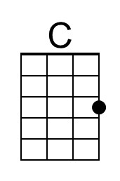
 | 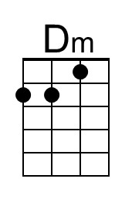
 | 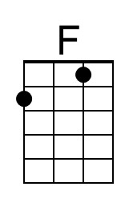
 | 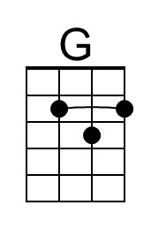
 | 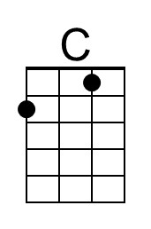
 | 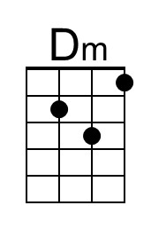
 | 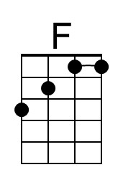
 | 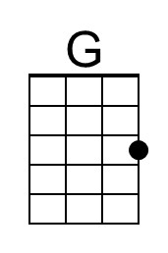

Sweet City Woman (Rich Dodson, 1971) (D)
Sweet City Woman by The Stampeders (1971)

Intro | D | D | Em | Em | Em | Em | D | D | (2x)  D Em | Em |  Well, I'm on my way, to the city lights.  D | D |  To a pretty face that shines her light on the city nights.  D Em | Em |  And I gotta catch a noon train, Gotta be there on time.  D | D |  Oh, it feels so good to know she waits at the end of the line.  Chorus  D Em | Em |  Swee-ee-eet, sweet city woman. I can see your face, I can hear your voice,  D | D | Em | Em |  I can almost touch you. Swee-ee-eet, sweet city woman  D | D |  Oh, my banjo and me, we got a feel for singin',  Bridge  yeah, yeah,  D G D  Bon c'est bon, bon bon c'est bon, bon. Bon c'est bon, bon, bon, bon, bon  D G D  Bon c'est bon, bon bon c'est bon, bon. Bon c'est bon, bon, bon, bon, bon  G D A D A D  So long ma. So long pa, So - long - Neighbors and friends  D Em | Em |  Like a country mornin', all smothered in dew.  E | E |  Ah she's got a way to make a man feel shiny and new  D Em | Em |  And she sing in the evenin', oid fa-mil-iar tunes  D | D |  And she feeds me love and tenderness and macaroons. Chorus Only  Outro  D Em A D | D  Swee-ee-eet, sweet city woman (oh, she's my), Sweet, sweet, sweet, sweet city woman  D Em A D | D  Swee-ee-eet, sweet city woman (oh, she's my), Sweet, sweet, sweet, sweet city woman  (Everybody)  D Em | Em  Sweet, sweet, sweet, sweet city woman (Ba da da da. Ba da da da) (3x)  A D D ˅ ˄ ˅ ˄ ˅ ˅ (Hold)  Sweet, sweet, sweet, sweet city wo - man. | 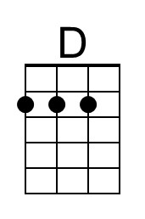
 | 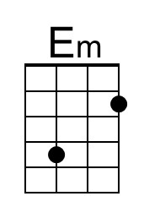
 | 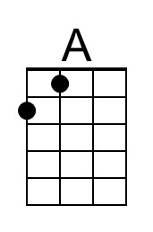
 | 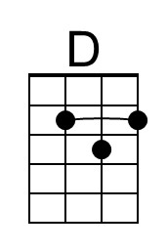
 | 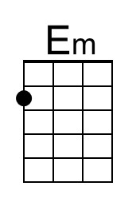
 | 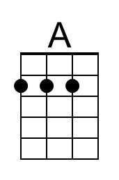

Sweet City Woman (Rich Dodson, 1971) (G)
Sweet City Woman by The Stampeders (1971)

Intro | G | G | Am | Am | Am | Am | G | G | (2x)

G Am | Am |
Well, I'm on my way, to the city lights.
G | G |
To a pretty face that shines her light on the city nights.
G Am | Am |
And I gotta catch a noon train, Gotta be there on time.
G | G |
Oh, it feels so good to know she waits at the end of the line.

Chorus
G Am | Am |
Swee-ee-eet, sweet city woman. I can see your face, I can hear your voice,
G | G | Am | Am |
I can almost touch you. Swee-ee-eet, sweet city woman
G | G |
Oh, my banjo and me, we got a feel for singin',

Bridge
yeah, yeah,
G C G
Bon c'est bon, bon bon c'est bon, bon. Bon c'est bon, bon, bon, bon, bon.
G C G
Bon c'est bon, bon bon c'est bon, bon. Bon c'est bon, bon, bon, bon, bon
C G D G D G
So long ma. So long pa, So - long - Neighbors and friends

G Am | Am |
Like a country mornin', all smothered in dew.
G | G |
Ah she's got a way to make a man feel shiny and new
G Am | Am |
And she sing in the evenin', oid fa-mil-iar tunes
G | G |
And she feeds me love and tenderness and macaroons. Chorus Only

Outro
G Am D G | G
Swee-ee-eet, sweet city woman (oh, she's my), Sweet, sweet, sweet, sweet city woman
G Am D G | G
Swee-ee-eet, sweet city woman (oh, she's my), Sweet, sweet, sweet, sweet city woman
(Everybody)
G Am | Am
Sweet, sweet, sweet, sweet city woman (Ba da da da. Ba da da da) (3x)
D G G ˅ ˄ ˅ ˄ ˅ ˅ (Hold)
Sweet, sweet, sweet, sweet city wo – man.
