Sweet City Woman (Rich Dodson, 1971) (C) (2/2 Time)
Sweet City Woman by The Stampeders (1971)

Intro (16 Measures) (2x)
C | C | Dm | Dm | Dm | Dm | C | C

C Dm | Dm |  1. Well, I'm on my way, to the city lights  Dm C  To a pretty face that shines her light on the city nights  C Dm | Dm |  And I gotta catch a noon train, Gotta be there on time  Dm C  Oh, it feels so good to know she waits at the end of the line. [Slide]  Chorus  C Dm | Dm |  Swee-ee-eet, sweet city woman.  Dm C  I can see your face, I can hear your voice, I can almost touch you.  C Dm | Dm |  Swee-ee-eet, sweet city woman  Dm C  Oh, my banjo and me, we got a feel for singin',  Bridge  (yeah, yeah,)  C C F C  Bon c'est bon, bon bon c'est bon, bon. Bon c'est bon, bon, bon, bon, bon.  C C F C  Bon c'est bon, bon bon c'est bon, bon. Bon c'est bon, bon, bon, bon, bon.  F C G C G C [Slide]  So long ma. So long pa. So long, neighbors and friends.  C Dm | Dm |  2. Like a country mornin', all smothered in dew  Dm C  Ah she's got a way to make a man feel shiny and new  C Dm | Dm |  And she sing in the evenin', old fam – i – li – ar tunes  Dm C  And she feeds me love and tenderness and macaroons. [Slide] Chorus |  |  |  |  |  |  | 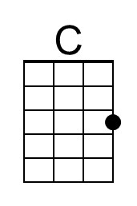
 |  |  |  |  |  |  | 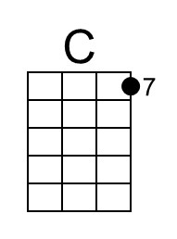
 |  |  |  |  |  |  | 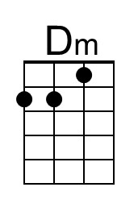
 |  |  |  |  |  |  | 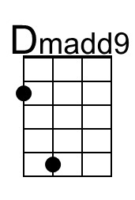
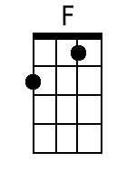
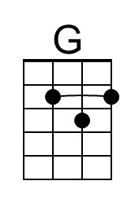
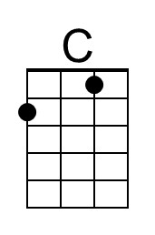 | 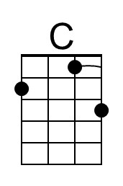 | 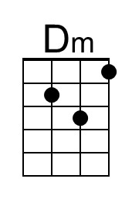 | 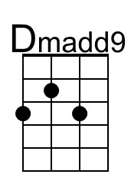 | 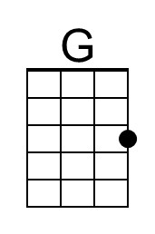 | 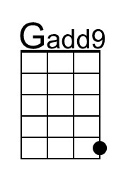 |  | 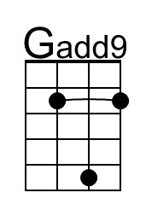

Sweet City Woman (C) – Page 2
Instrumental break – 8 measures
C | C | Dm | Dm | Dm | Dm | C | C

Chorus

Outro:
C Dm
Daaa da da | da da daaa da da | Da do do do do do dooo do | oo.
Dm C
Da da | da da daa da da da da | daa da da da da daa | Do do do do da do do | ooo.

C Dm Dm C
Swee-ee-eet, sweet city woman. Oh, she's my sweet, sweet, sweet, sweet city woman.
C Dm Dm C
Swee-ee-eet, sweet city woman. Oh, she's my sweet, sweet, sweet, sweet city woman.

Dm C | Dm |
Sweet, sweet, sweet, sweet city woman. (da da daaa da). 3x Repeat

Dm C↓ C↓ (Hold)
Sweet, sweet, sweet, sweet city wo-man.

 |  |  |  |  |  | 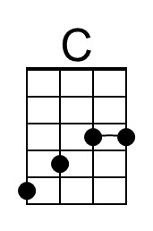 | 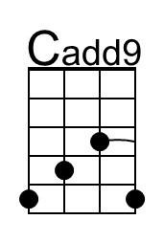
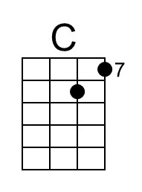 | 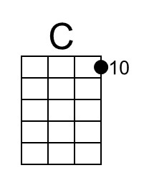 | 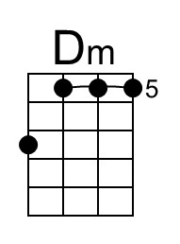 | 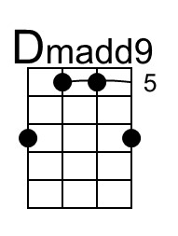 | 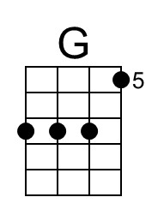 | 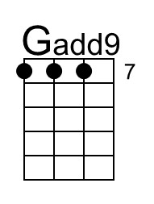 | 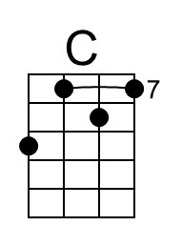 | 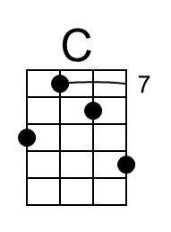
Bari |  |  |  |  |  |  | 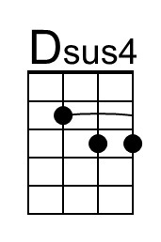  ?
 | 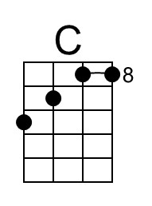 | 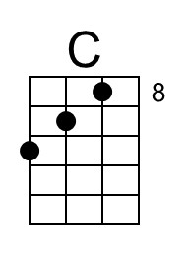 | 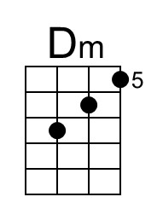 | 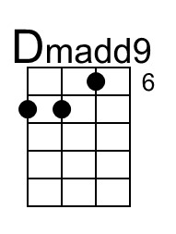 | 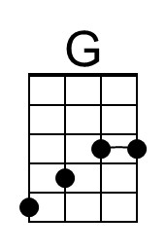 | 