Sweet City Woman (Rich Dodson, 1971) (C)
Sweet City Woman by The Stampeders (1971)

Intro | C | C | Dm | Dm | Dm | Dm | C | C | (2x)  C Dm | Dm |  Well, I'm on my way, to the city lights.  C | C |  To a pretty face that shines her light on the city nights.  C Dm | Dm |  And I gotta catch a noon train, Gotta be there on time.  C | C |  Oh, it feels so good to know she waits at the end of the line.  Chorus  C Dm | Dm |  Swee-ee-eet, sweet city woman. I can see your face, I can hear your voice,  C | C | Dm | Dm |  I can almost touch you. Swee-ee-eet, sweet city woman  C | C |  Oh, my banjo and me, we got a feel for singin',  Bridge  yeah, yeah,  C F C  Bon c'est bon, bon bon c'est bon, bon. Bon c'est bon, bon, bon, bon, bon  C F C  Bon c'est bon, bon bon c'est bon, bon. Bon c'est bon, bon, bon, bon, bon  F C G C G C  So long ma. So long pa, So - long - Neighbors and friends  C Dm | Dm |  Like a country mornin', all smothered in dew.  C | C |  Ah she's got a way to make a man feel shiny and new  C Dm | Dm |  And she sing in the evenin', oid fa-mil-iar tunes  C | C |  And she feeds me love and tenderness and macaroons. Chorus Only  Outro  C Dm G C | C  Swee-ee-eet, sweet city woman (oh, she's my), Sweet, sweet, sweet, sweet city woman  C Dm G C | C  Swee-ee-eet, sweet city woman (oh, she's my), Sweet, sweet, sweet, sweet city woman  (Everybody)  C Dm | Dm  Sweet, sweet, sweet, sweet city woman (Ba da da da. Ba da da da) (3x)  G C C ˅ ˄ ˅ ˄ ˅ ˅ (Hold)  Sweet, sweet, sweet, sweet city wo - man. | 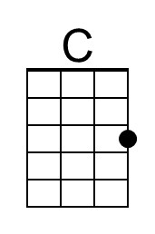
 | 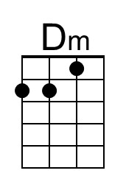
 | 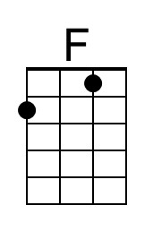
 | 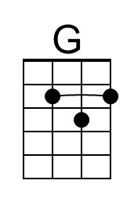
 | 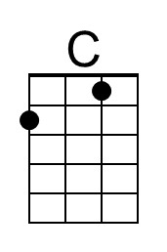
 | 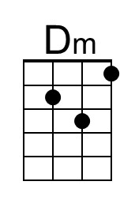
 | 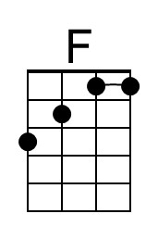
 | 