Sweet City Woman (Rich Dodson, 1971) (D)
Sweet City Woman by The Stampeders (1971)

Intro | D | D | Em | Em | Em | Em | D | D | (2x)  D Em | Em |  Well, I'm on my way, to the city lights.  D | D |  To a pretty face that shines her light on the city nights.  D Em | Em |  And I gotta catch a noon train, Gotta be there on time.  D | D |  Oh, it feels so good to know she waits at the end of the line.  Chorus  D Em | Em |  Swee-ee-eet, sweet city woman. I can see your face, I can hear your voice,  D | D | Em | Em |  I can almost touch you. Swee-ee-eet, sweet city woman  D | D |  Oh, my banjo and me, we got a feel for singin',  Bridge  yeah, yeah,  D G D  Bon c'est bon, bon bon c'est bon, bon. Bon c'est bon, bon, bon, bon, bon  D G D  Bon c'est bon, bon bon c'est bon, bon. Bon c'est bon, bon, bon, bon, bon  G D A D A D  So long ma. So long pa, So - long - Neighbors and friends  D Em | Em |  Like a country mornin', all smothered in dew.  E | E |  Ah she's got a way to make a man feel shiny and new  D Em | Em |  And she sing in the evenin', oid fa-mil-iar tunes  D | D |  And she feeds me love and tenderness and macaroons. Chorus Only  Outro  D Em A D | D  Swee-ee-eet, sweet city woman (oh, she's my), Sweet, sweet, sweet, sweet city woman  D Em A D | D  Swee-ee-eet, sweet city woman (oh, she's my), Sweet, sweet, sweet, sweet city woman  (Everybody)  D Em | Em  Sweet, sweet, sweet, sweet city woman (Ba da da da. Ba da da da) (3x)  A D D ˅ ˄ ˅ ˄ ˅ ˅ (Hold)  Sweet, sweet, sweet, sweet city wo - man. | 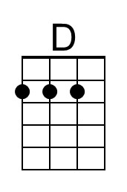
 | 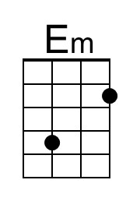
 | 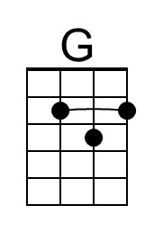
 | 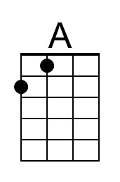
 | 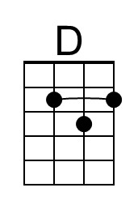
 | 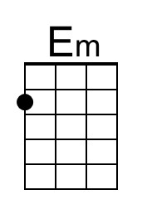
 | 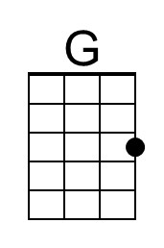
 | 