Sweet City Woman (Rich Dodson, 1971) (G) (2/2 Time)
Sweet City Woman by The Stampeders (1971)

Intro (16 Measures) (2x)
G | G | Am | Am | Am | Am | G | G
G Am | Am  1. Well, I'm on my way, to the city lights  Am G | G  To a pretty face that shines her light on the city nights  G Am | Am  And I gotta catch a noon train, Gotta be there on time  Am G | G [Slide]  Oh, it feels so good to know she waits at the end of the line.  Chorus  G Am | Am Am  Swee-ee-eet, sweet city woman. I can see your face, I can hear your voice,  G | G | G Am | Am  I can almost touch you. Swee-ee-eet, sweet city woman  Am G | G  Oh, my banjo and me, we got a feel for singin',  Bridge  (yeah, yeah)  G G C G  Bon, c'est bon _ bon, bon, c'est bon, bon. Bon, c'est bon, bon, bon, bon, bon.  G G C G  Bon, c'est bon _ bon, bon, c'est bon, bon. Bon, c'est bon, bon, bon, bon, bon.  C G D G D G [Slide]  So long ma, so long pa, so long neighbors and friends.  G Am | Am  2. Like a country mornin', all smothered in dew  Am G | G  Ah she's got a way to make a man feel shiny and new.  G Am | Am  And she sing in the evenin', old fam - i - li - ar tunes,  Am G | G [Slide] Chorus  And she feeds me love and tender-ness and macaroons. |  |  |  |  |  |  | 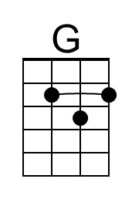
 |  |  |  |  |  |  | 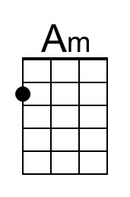
 |  |  |  |  |  |  | 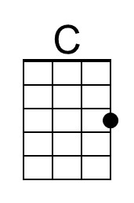
 |  |  |  |  |  |  | 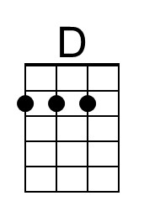
Bari
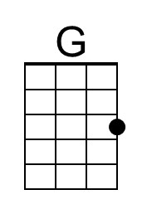 | 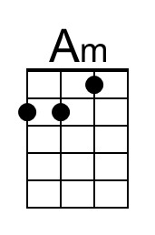 | 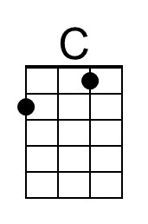 | 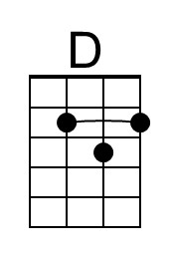 | 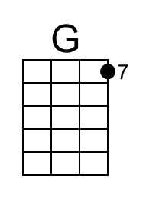 | 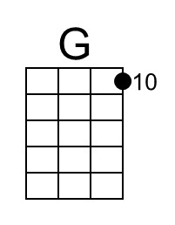 | 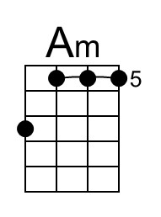 | 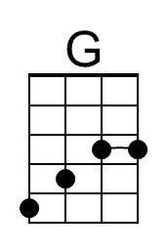

Sweet City Woman (G) – Page 2

Instrumental break – 8 measures
G | G | Am | Am | Am | Am | G | G

Chorus

Outro:
G Am
Daaa da da | da da daaa da da | Da do do do do do do do | oo. _ da da
Am G | G
Da da daaa da da da da | daa da da da da daaa | Do do do do _ do do do | ooo.

G Am | Am Am G | G
Swee-ee-eet, sweet city woman. Oh, she's my sweet, sweet, sweet, sweet city woman.
G Am | Am Am G | G
Swee-ee-eet, sweet city woman. Oh, she's my sweet, sweet, sweet, sweet city woman.

Am G | Am |
Sweet, sweet, sweet, sweet city woman (da da daaa da). 3x Repeat

Am G↓ G↓ (Hold)
Sweet, sweet, sweet, sweet city wo-man.

C-Tuning
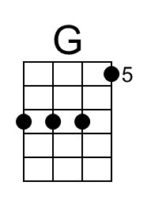 | 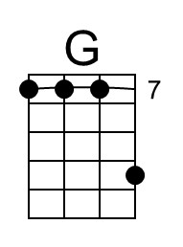 | 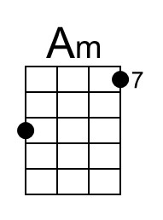 | 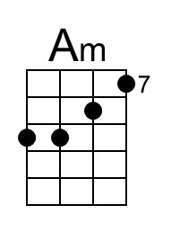
G-Tuning
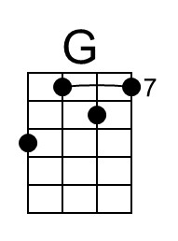 | 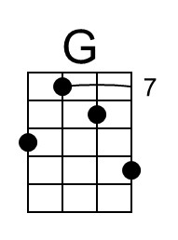 |  | 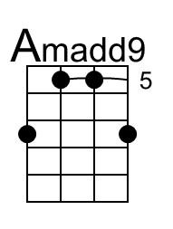 |  | 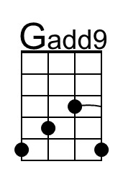
 |  |  | 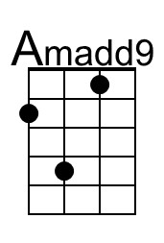 |  | 