Sweet City Woman - The Stampeders (1971)
2/2 Time – Key of G
Sweet City Woman by The Stampeders (1971) (Studio Version)
Sweet City Woman by The Stampeders (Official Video)

Intro (16 Measures)
G | G | Am | Am | Am | Am | G | G
G | G | Am | Am | Am | Am | G | G
G Am | Am  1. Well, I'm on my way, to the city lights  Am G  To a pretty face that shines her light on the city nights  G  And I gotta catch a noon train  Am | Am  Gotta be there on time  Am G  Oh, it feels so good to know she waits at the end of the line  Chorus  G Am | Am  Swee-ee-eet, sweet city woman  Am  I can see your face, I can hear your voice,  G  I can almost touch you  G Am | Am  Swee-ee-eet, sweet city woman  Am G  Oh, my banjo and me, we got a feel for singin', yeah, yeah,  Bridge  G  Bon c'est bon, bon bon c'est bon, bon,  G C G  Bon c'est bon, bon, bon, bon, bon  G  Bon c'est bon, bon bon c'est bon, bon,  G C G  Bon c'est bon, bon, bon, bon, bon  C G D G D  So long ma, so long pa, so long  G  Neighbors and friends. |  |  |  |  |  |  | 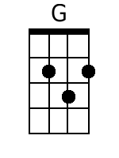
 |  |  |  |  |  |  | 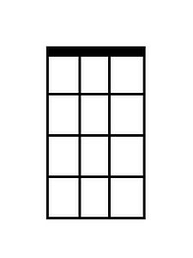
 |  |  |  |  |  |  | 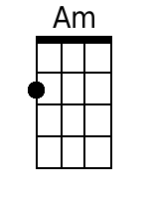
 |  |  |  |  |  |  | 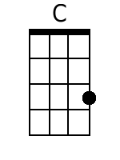
 |  |  |  |  |  |  | 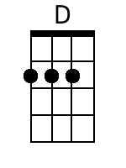
Bari
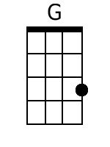 |  | 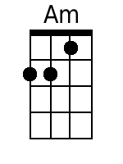 |  | 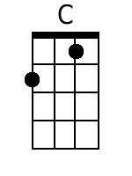 | 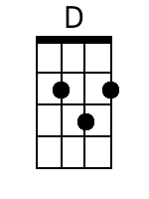
G Am | Am
2. Like a country mornin', all smothered in dew
Am G
Ah she's got a way to make a man feel shiny and new
G Am | Am
And she sing in the evenin', old fam - i - li - ar tunes
Am G
And she feeds me love and tender-ness and macaroons.

Chorus
G Am | Am
Swee-ee-eet, sweet city woman
Am
I can see your face, I can hear your voice,
G
I can almost touch you
G Am | Am
Swee-ee-eet, sweet city woman
Am G
Oh, my banjo and me, we got a feel for singin', yeah, yeah,

Instrumental break – 8 measures
G | G | Am | Am | Am | Am | G | G

Outro:
G
Daaa da da | da da daaa da da |
Am
Da do do do do do do do | oo.
Am G
Da da | da da daa da da da da | daa da da da da daa | Do do do do da do do | ooo.

2x Repeat
G Am
Swee-ee-eet, sweet city woman.
Am C
Oh, she's my sweet, sweet, sweet, sweet city woman.

2x Repeat and fade.
Am | Am |
Sweet, sweet, sweet, sweet city woman.

Sweet City Woman - The Stampeders (1971)
2/2 Time – Key of C
Sweet City Woman by The Stampeders (1971) (Studio Version)
Sweet City Woman by The Stampeders (Official Video)

Intro (16 Measures):
C | C | Dm | Dm | Dm | Dm | C | C
C | C | Dm | Dm | Dm | Dm | C | C

C Dm | Dm |
1. Well, I'm on my way, to the city lights
Dm C
To a pretty face that shines her light on the city nights
C
And I gotta catch a noon train
Dm | Dm |
Gotta be there on time
Dm C
Oh, it feels so good to know she waits at the end of the line

Chorus
C Dm | Dm |
Swee-ee-eet, sweet city woman
Dm
I can see your face, I can hear your voice,
C
I can almost touch you
C Dm | Dm |
Swee-ee-eet, sweet city woman
Dm C
Oh, my banjo and me, we got a feel for singin', yeah, yeah,

Bridge
C
Bon c'est bon, bon bon c'est bon, bon,
C F C
Bon c'est bon, bon, bon, bon, bon
C
Bon c'est bon, bon bon c'est bon, bon,
C F C
Bon c'est bon, bon, bon, bon, bon
F C G C G
So long ma, so long pa, so long
C
Neighbors and friends.
 |  |  |  |  |  |  | 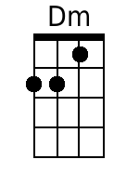
 |  |  |  |  |  |  | 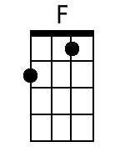
Bari
 |  | 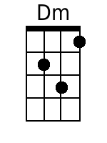 |  | 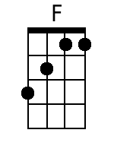
C Dm | Dm |
2. Like a country mornin', all smothered in dew
Dm C
Ah she's got a way to make a man feel shiny and new
C Dm | Dm |
And she sing in the evenin', old fam – i – li – ar tunes
Dm C
And she feeds me love and tenderness and macaroons.

Chorus
C Dm | Dm |
Swee-ee-eet, sweet city woman
Dm
I can see your face, I can hear your voice,
C
I can almost touch you
C Dm | Dm |
Swee-ee-eet, sweet city woman
Dm C
Oh, my banjo and me, we got a feel for singin', yeah, yeah,

Instrumental break – 8 measures
C | C | Dm | Dm | Dm | Dm | C | C

Outro:
C
Daaa da da | da da daaa da da |
Dm
Da do do do do do dooo do | oo.
Dm C
Da da | da da daa da da da da | daa da da da da daa | Do do do do da do do | ooo.

2x Repeat
C Dm
Swee-ee-eet, sweet city woman.
Dm C
Oh, she's my sweet, sweet, sweet, sweet city woman.

2x Repeat and fade.
Dm | Dm |
Sweet, sweet, sweet, sweet city woman.

