Sweet Georgia Brown
605C
(Ben Bernie, Maceo Pinkard, Kenneth Casey, 1925)

Intro (Instrumental – Chords for last line of verse)  C A7 D7 G7 C - E7  Georgia claimed her, Georgia named her, Sweet Georgia Brown.  Reprise  A7  No gal made has got a shade on. . . sweet Georgia Brown  D7  Two left feet but oh so neat has. . . sweet Georgia Brown  G7  They all sigh and wanna’ die for. . . sweet Georgia Brown  C G7 C E7  I’ll tell you just why, you know I don’t lie, Not much!  A7  It’s been said she knocks ‘em dead when. . . she lands in town  D7  Since she came, why it’s a shame how. . . she cools ‘em down  Am E7 Am E7  Fellers she can’t get are fellers she ain’t met.  C A7 D7 G7 C  Georgia claimed her, Georgia named her, Sweet Georgia Brown. Reprise  A7  All those tips the porter slips to. . . sweet Georgia Brown  D7  They buy clothes at fashions shows with. . . one dollar down  Am E7 Am E7  Oh boy, tip your hats! Oh joy, she’s the “cat’s”!  C A7 D7 G7 C  Who’s that mister? ‘Tain’t her sister, Sweet Georgia Brown.  Outro (Ritard.)  C A7 D7 G7 C  Georgia claimed her, Georgia named her, Sweet Georgia Brown. |  |  |  |  |  |  | 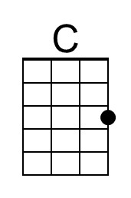
 |  |  |  |  |  |  | 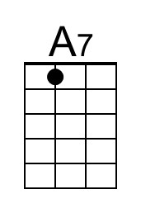
 |  |  |  |  |  |  | 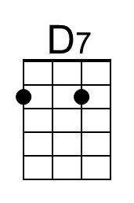
 |  |  |  |  |  |  | 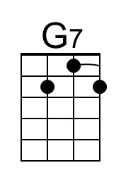
 |  |  |  |  |  |  | 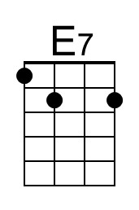
 |  |  |  |  |  |  | 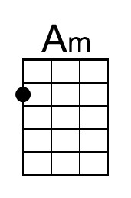
Bari | 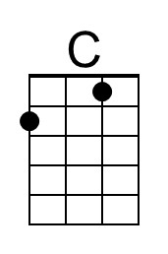 | 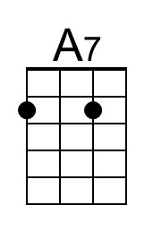 | 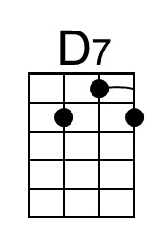 | 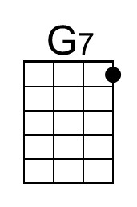 | 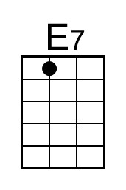 | 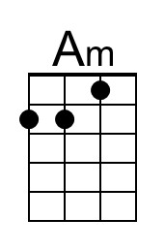


Sweet Georgia Brown
605F
(Ben Bernie, Maceo Pinkard, Kenneth Casey, 1925)

Intro (Instrumental – Chords for last line of verse)  F D7 G7 C7 F  Georgia claimed her, Georgia named her, Sweet Georgia Brown.  Reprise  D7  No gal made has got a shade on ….sweet Georgia Brown  G7  Two left feet but oh so neat has ….sweet Georgia Brown  C7  They all sigh and wanna’ die for…sweet Georgia Brown  F C7 F A7  I’ll tell you just why, you know I don’t lie, Not much!  D7  It’s been said she knocks ‘em dead when ….she lands in town  G7  Since she came, why it’s a shame how ….she cools ‘em down  Dm A7 Dm A7  Fellers she can’t get are fellers she ain’t met.  F D7 G7 C7 F  Georgia claimed her, Georgia named her, Sweet Georgia Brown. Reprise  D7  All those tips the porter slips to. . . sweet Georgia Brown  G7  They buy clothes at fashions shows ….with one dollar down  Dm A7 Dm A7  Oh boy, tip your hats! Oh joy, she’s the “cat’s”!  F D7 G7 C7 F  Who’s that mister? ‘Tain’t her sister, Sweet Georgia Brown.  Outro (Ritard.)  F D7 G7 C7 F  Georgia claimed her, Georgia named her, Sweet Georgia Brown. |  |  |  |  |  |  | 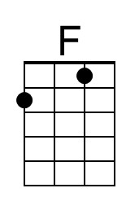
 |  |  |  |  |  |  | 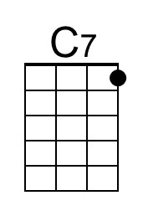
Bari | 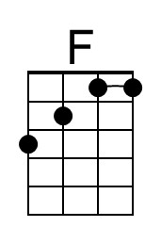 |  |  | 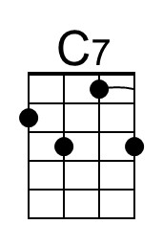 |  | 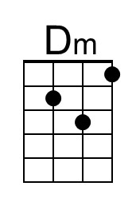 | 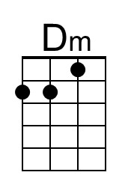

Sweet Georgia Brown
605G
(Ben Bernie, Maceo Pinkard, Kenneth Casey, 1925)

Intro (Instrumental – Chords for last line of verse)  G E7 A7 D7 G - B7  Georgia claimed her, Georgia named her, Sweet Georgia Brown.  Reprise  E7  No gal made has got a shade on ….sweet Georgia Brown  A7  Two left feet but oh so neat has ….sweet Georgia Brown  D7  They all sigh and wanna’ die for…sweet Georgia Brown  G D7 G B7  I’ll tell you just why, you know I don’t lie, Not much!  E7  It’s been said she knocks ‘em dead when ….she lands in town  A7  Since she came, why it’s a shame how ….she cools ‘em down  Em B7 Em B7  Fellers she can’t get are fellers she ain’t met.  G E7 A7 D7 G  Georgia claimed her, Georgia named her, Sweet Georgia Brown. Reprise  E7  All those tips the porter slips to. . . sweet Georgia Brown  A7  They buy clothes at fashions shows with ….one dollar down  Em B7 Em B7  Oh boy, tip your hats! Oh joy, she’s the “cat’s”!  G E7 A7 D7 G  Who’s that mister? ‘Tain’t her sister, Sweet Georgia Brown  Outro (Ritard.)  G E7 A7 D7 G  Georgia claimed her, Georgia named her, Sweet Georgia Brown. |  |  |  |  |  |  | 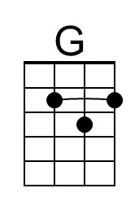
 |  |  |  |  |  |  | 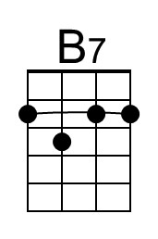
 |  |  |  |  |  |  | 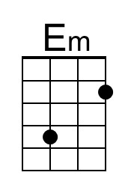
Bari | 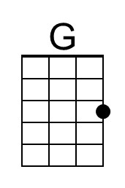 |  |  |  | 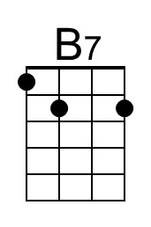 | 