**Sweet Georgia Brown**

**(Ben Bernie, Maceo Pinkard, Kenneth Casey)**

**Intro: (Chords for Reprise)**

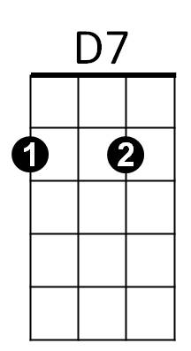

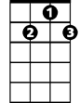

G7

**D7**

No gal made has got a shade on ….sweet Georgia Brown

**G7**

Two left feet but oh so neat has sweet Georgia Brown

**C7**

They all sigh and wanna’ die for…sweet Georgia Brown

**F A7**

F

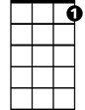

C7

I’ll tell you just why, you know I won’t lie (not much!)

**D7**

It’s been said she knocks ‘em dead when she lands in town

**G7**

Since she came, why it’s a shame how she cools ‘em down

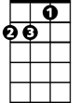

Dm

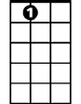

A7

**Dm A7 Dm A7**

Fellas she can’t get are fellas she ain’t met

**F D7**

Georgia claimed her, Georgia named her

**G7 C7 F**

Sweet Georgia Brown

**D7**

No gal made has got a shade on ….sweet Georgia Brown

**BARITONE**

**G7**



D7



G7

Two left feet but oh so neat has sweet Georgia Brown

**C7**

They all sigh and wanna’ die for…sweet Georgia Brown

**F A7**

I’ll tell you just why, you know I won’t lie (not much!)



F

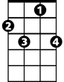

C7

**D7**

All those gifts the courters give to sweet Georgia Brown

**G7**

They buy clothes at fashions shows, with one dollar down

**Dm A7 Dm A7**

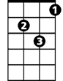

Dm

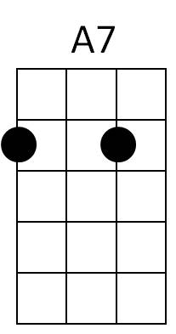Oh boy, tip your hat! Oh joy, she’s the cat!

**F D7 G7 C7 F**

Who’s that mister? ‘Tain’t no sister, Sweet Georgia Brown

**F D7 G7 C7 F**

Georgia claimed her, Georgia named her, Sweet Georgia Brown