**Sweet Lady of Waiahole (Bruddah Waltah) Key C** (Reggae beat)

**C**

Early in the morning, she would gather all her island fruits

**C7 F**

And pack them as she starts another day

**Fm**

Carefully she makes her way,

**C Am**

Beside the mountain stream

**Dm G7 C G7**

As she sings and island chant of long ago

**Chorus**

**C F**

My sweet lady of Waiahole,

**C**

She’s sitting by the highway

(by the highway, sitting by the highway)

**Dm**

Selling her papaya

(papaya - pa pa paya)

**G7 C G7**

And her green and ripe banana

**C**

Walking down her damp and rocky road her humble wagon stops

**C7**

She watched the sun creep through the valley

**F**

sky

**Fm C**

Smiles and wipes the sweat off from her brow,

**Am**

Continue moves on

**Dm G7**

And starts her journey through the highway rising **C G7**

sun

**(Chorus)**

**Instrumental verse (OPTIONAL)**

**C**

Later in the evening, she would gather all her island fruits

**C7 F**

And pack them as she ends another day

**Fm**

Carefully she makes her way,

**C Am**

Beside the mountain stream

**Dm G7 C G7**

As she sings and island chant of long ago

**(Chorus)**

**C Dm**

Selling her papaya (papaya pa pa paya)

**G7 C G7 C G7 C**

And her green and ripe banana

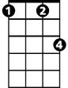

Fm



C

F

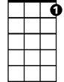

C7

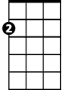

Am

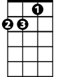

Dm

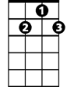

G7

**BARITONE**

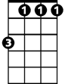

Fm

C

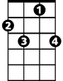

C7



F



G7



Am

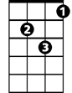

Dm

**Sweet Lady of Waiahole (Bruddah Waltah) Key F** (Reggae beat)

**F**

Early in the morning, she would gather all her island fruits

**F7 Bb**

And pack them as she starts another day

**Bbm**

Carefully she makes her way,

**F Dm**

Beside the mountain stream

**Gm C7 F C7**

As she sings and island chant of long ago

**Chorus**

**F Bb**

My sweet lady of Waiahole,

**F**

She’s sitting by the highway

(by the highway, by the highway)

**Gm**

Selling her papaya

(papaya - pa pa paya)

**C7 F C7**

And her green and ripe banana

**F**

Walking down her damp and rocky road her humble wagon stops

**F7 Bb**

She watched the sun creep through the valley sky

**Bbm F**

Smiles and wipes the sweat off from her brow,

**Dm**

Continue moves on

**Gm C7**

And starts her journey through the highway rising **F C7**

sun

**(Chorus)**

**Instrumental verse (Optional)**

**F**

Later in the evening, she would gather all her island fruits

**F7 Bb**

And pack them as she ends another day

**Bbm**

Carefully she makes her way,

**F Dm**

Beside the mountain stream

**Gm C7 F C7**

As she sings and island chant of long ago

**(Chorus)**

**F Gm**

Selling her papaya (papaya pa pa paya)

**C7 F C7**  **F C7 F**

And her green and ripe banana



Bb m



Bb

F



F7



C7



Gm



Dm

**BARITONE**



C7

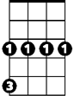

Gm



F

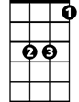

Bb

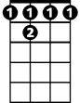

F 7

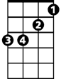

Bb m



Dm