**Sweet Violets (Charles Green / Cy Coben)**

**G D7**

There once was a farmer who took a young miss

In back of the barn where he gave her a -

**G D7**

**Lecture** on horses and chickens and eggs,

And told her that she has such beautiful -

**G D7**

**Manners** that suited a girl of her charms,

A girl that he'd like for to take in his -

**G D7**

**Washing** and ironing, and then if she did,

They could get married and raise lots of -

**Chorus:**

**G D7**

Sweet violets, sweeter than all the roses,

Covered all over from head to toe,

**G C G**

Covered all over with sweet vio-lets.

**G D7**

The girl told the farmer that he'd better stop,

And she told her father and called a-

**G D7**

**Taxi** which got there before very long,

For someone was doing his little girl –

**BARITONE**

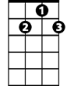

D7

C



G

**G D7**

**Right** for a change, and so here's what he said:

"If you marry her, son, you're better off –

**G D7**

**Single** 'cause it's been my belief,

All a man gets out of marriage is-

**(Chorus)**

**G D7**

The farmer decided he'd wed anyway,

And started in planning for his wedding –

**G D7**

**Suit** which he'd purchased for only one buck,

But then he found out he was just out of -

**G D7**

**Money** and so he got left in the lurch,

Standing and waiting in front of the –

**G D7**

**End** of this story, which just goes to show,

All a girl wants from a man is his-

**(Chorus)**

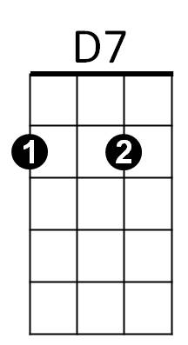



C



G