Swing Low, Sweet Chariot
Traditional
Swing Low, Sweet Chariot (Traditional) (C)

Chorus
G7 C F C
Swing low, sweet chari-ot,
G7
Coming for to carry me home
C F C
Swing low, sweet chari-ot,
G7 C
Coming for to carry me home

C F C
I looked over Jordan and what did I see
G7
Coming for to carry me home
C F C
A band of angels a-coming after me
G7 C
Coming for to carry me home. Chorus

C F C
Well sometimes I’m up, and sometimes I’m down
G7
Coming for to carry me home
C F C
But still my soul is heavenly bound
G7 C
Coming for to carry me home. Chorus

C F C
Well if you get there before I do
G7
Coming for to carry me home
C F C
Tell all my friends I’m a-coming too
G7 C
Coming for to carry me home. Chorus
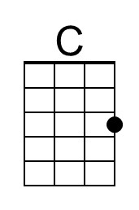 | 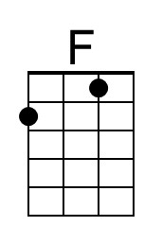 | 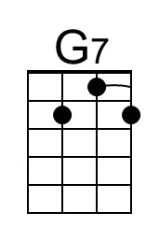 |  | Bari | 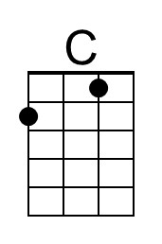 | 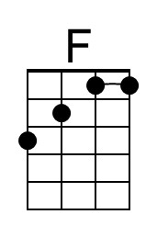 | 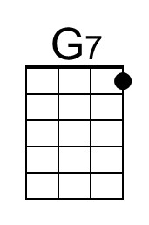
Swing Low, Sweet Chariot (Traditional) (G)

Chorus
D7 G C G
Swing low, sweet chari-ot,
D7
Coming for to carry me home
G C G
Swing low, sweet chari-ot,
D7 G
Coming for to carry me home

G C G
I looked over Jordan and what did I see
D7
Coming for to carry me home
G C G
A band of angels a-coming after me
D7 G
Coming for to carry me home. Chorus

G C G
Well sometimes I’m up, and sometimes I’m down
D7
Coming for to carry me home
G C G
But still my soul is heavenly bound
D7 G
Coming for to carry me home. Chorus

G C G
Well if you get there before I do
D7
Coming for to carry me home
G C G
Tell all my friends I’m a-coming too
D7 G
Coming for to carry me home. Chorus

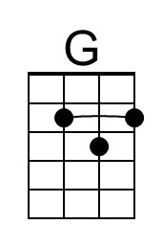 |  | 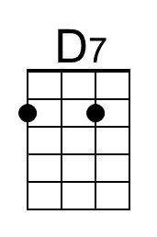 |  | Bari | 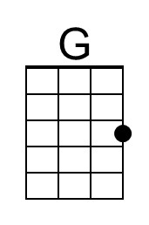 |  | 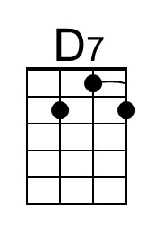
Swing Low, Sweet Chariot (Traditional) (F)

Chorus
C7 F B♭ F
Swing low, sweet chari-ot,
C7
Coming for to carry me home
F B♭ F
Swing low, sweet chari-ot,
C7 F
Coming for to carry me home

F B♭ F
I looked over Jordan and what did I see
C7
Coming for to carry me home
F B♭ F
A band of angels a-coming after me
C7 F
Coming for to carry me home. Chorus

F B♭ F
Well sometimes I’m up, and sometimes I’m down
C7
Coming for to carry me home
F B♭ F
But still my soul is heavenly bound
C7 F
Coming for to carry me home. Chorus

F B♭ F
Well if you get there before I do
C7
Coming for to carry me home
F B♭ F
Tell all my friends I’m a-coming too
C7 F
Coming for to carry me home. Chorus

 | 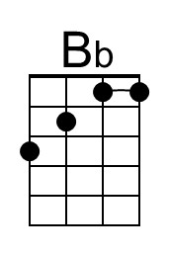 | 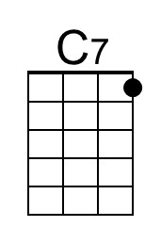 |  | Bari |  | 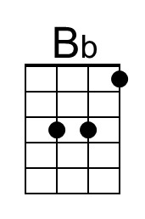 | 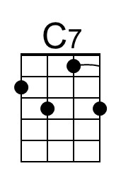
Swing Low, Sweet Chariot (Traditional) (C)

Chorus
G7 C F C
Swing low, sweet chari-ot,
G7
Coming for to carry me home
C F C
Swing low, sweet chari-ot,
G7 C
Coming for to carry me home

C F C
I looked over Jordan and what did I see
G7
Coming for to carry me home
C F C
A band of angels a-coming after me
G7 C
Coming for to carry me home. Chorus

C F C
Well sometimes I’m up, and sometimes I’m down
G7
Coming for to carry me home
C F C
But still my soul is heavenly bound
G7 C
Coming for to carry me home. Chorus

C F C
Well if you get there before I do
G7
Coming for to carry me home
C F C
Tell all my friends I’m a-coming too
G7 C
Coming for to carry me home. Chorus
Bari

This page is intentionally blank.

