'Zat You, Santa Claus? (Jack Fox, 1953)
C100-Am
'Zat you, Santa Claus? by Louis Armstrong and the Commanders, 1953

Intro Am G F E7 Am G F E7

Am G F E7
Gifts I'm preparin' for some Christmas sharin'
Am G F - E7 Am G
But I pause be-cause hangin' my stockin'
F E7 Dm E7
I can hear a knockin'. 'Zat you, Santa Claus?

Am G F E7
Sure is dark out, ain’t the slighest spark out
Am G F - E7 Am G
Pardon my clackin' jaws! Who’s there? Who is it?
F E7 Dm E7
Uh, stoppin' for a visit? Is 'Zat you, Santa Claus?
A7 Dm
Are you bringin' a present for me
A7 Dm
Something pleasantly pleasant for me
G Dm
Bet it’s just what I've been waitin' for
E E7
Would you mind slippin' it under the door?

Am G F E7
Cold winds are howlin' Or could that be growlin'?
Am G F - E7 Am G
My legs feel like straws My, my, oh me, my
F E7 Dm E7
Kindly will you reply, is ‘zat you, Santa Claus?
A7 Dm
Whoa there, Santa, you gave me a scare
A7
__ Now stop your teasin', 'cause
Dm
I know you're there
G Dm
__We don't believe in no goblins today,
E E7
But, I can't explain why I'm a-shakin' this way

Am G F E7
Bet I can see ole Santa through the keyhole,
Am G F - E7 Am G
I'll get to the cause. One peek and I'll try there,
F E7 Dm E7
Uh-oh there's an eye there, 'Zat you, Santa Claus?
E7
Please, oh please, I’m bendin’ my knees,
Dm E7 Am G F E7
Say that's you, __ Santa Claus!
Am G F E7 Am
Spoken: That's him alright! (jingle, jingle)

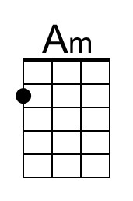 | 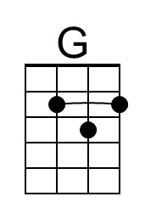 | 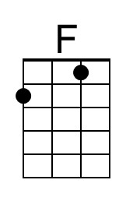 | 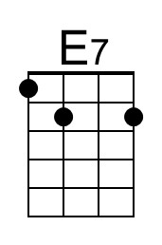 | 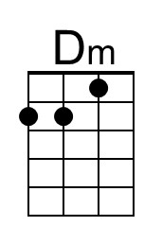 | 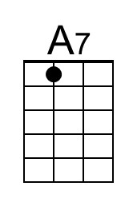 | 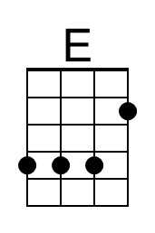
 | Bari | 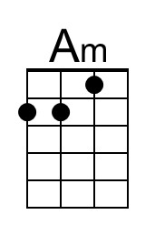 | 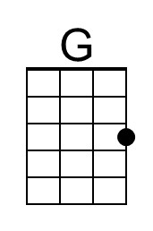 | 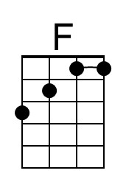 | 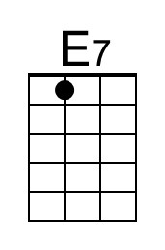 | 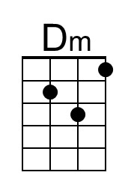 | 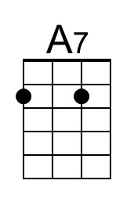 | 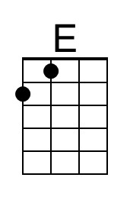

'Zat You, Santa Claus? (Jack Fox, 1953)
C100-Em
'Zat you, Santa Claus? by Louis Armstrong and the Commanders, 1953

Intro Em D C B7 Em D C B7

Em D C B7
Gifts I'm preparin' for some Christmas sharin'
Em D C - B7 Em D
But I pause be-cause hangin' my stockin'
C B7 Am B7
I can hear a knockin'. 'Zat you, Santa Claus?

Em D C B7
Sure is dark out, ain’t the slighest spark out
Em D C - B7 Em D
Pardon my clackin' jaws! Who’s there? Who is it?
C B7 Am B7
Uh, stoppin' for a visit? Is 'Zat you, Santa Claus?
E7 Am
Are you bringin' a present for me
E7 Am
Something pleasantly pleasant for me
D Am
Bet it’s just what I've been waitin' for
B B7
Would you mind slippin' it under the door?

Em D C B7
Cold winds are howlin' Or could that be growlin'?
Em D C - B7 Em D
My legs feel like straws My, my, oh me, my
C B7 Am B7
Kindly will you reply, is ‘zat you, Santa Claus?
E7 Am
Whoa there, Santa, you gave me a scare
E7
__ Now stop your teasin', 'cause
Am
I know you're there
D Am
__We don't believe in no goblins today,
B B7
But, I can't explain why I'm a-shakin' this way

Em D C B7
Bet I can see ole Santa through the keyhole,
Em D C - B7 Em D
I'll get to the cause. One peek and I'll try there,
C B7 Am B7
Uh-oh there's an eye there, 'Zat you, Santa Claus?
B7
Please, oh please, I’m bendin’ my knees,
Am B7 Em D C B7
Say that's you, __ Santa Claus!
Em D C B7 Em
Spoken: That's him alright! (jingle, jingle)

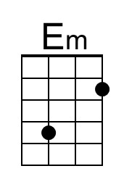 | 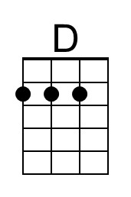 | 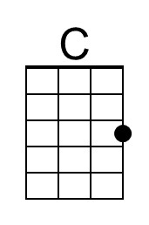 | 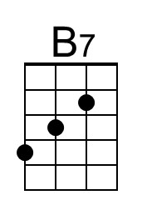 |  |  | 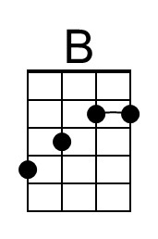  B
 | Bari | 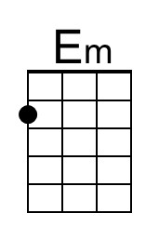 | 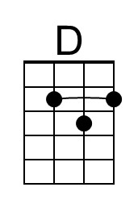 | 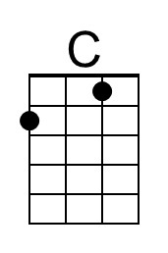 | 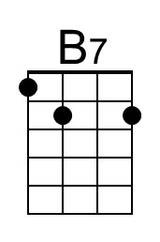 |  |  | 