Take Me Home, Country Road (John Denver / Cousin IZ)
Key of C – Ukulele Chord Charts
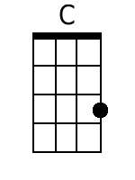  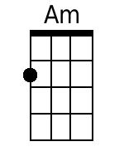  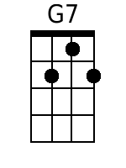  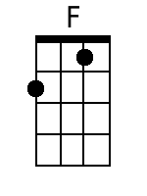  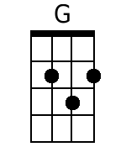  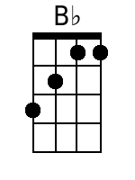  Bari  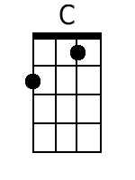  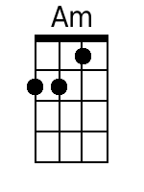  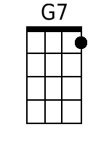  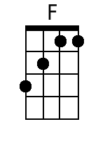  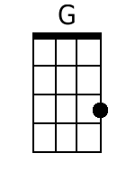  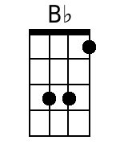 | Intro: C  C Am  Almost heaven, West Makaha,  G7 F C  High-ridge Mountains, crystal clear blue water  C Am  All my friends there, hanging on the beach,  G7 F C  Young and old among them, feel the ocean breeze  CHORUS:  C G7 Am F  Country road, take me home, To the place, I belong  C G7 F C  West Makaha, Mount Ka’ala, Take me home, oh country road  BRIDGE:  Am G C  I heard a voice, in the morning calm she calls me  F C G  As though to remind me of my home far a-way  Am B♭ F  Driving down the road I feel the Spirit coming to me,  G G7  From yesterday, yesterday.  C Am  All my memories hold Heaven on high,  G7 F C  Brown skinned woman, clear blue island sky  C Am  Daytime sunshine, ooo-oh so bright,  G7 F C  Midnight moon a-glowing, stars up in the sky  CHORUS:  C G7 Am F  Country road, take me home, To the place, I belong  C G7 F C  West Makaha, Mount Ka’ala, Take me home, oh country road  BRIDGE:  Am G C  I heard a voice, in the morning calm she calls me  F C G  As though to remind me of my home far a-way  Am B♭ F  Driving down the road I feel the Spirit coming to me,  G G7  From yesterday, yesterday.  C Am  Almost heaven, West Makaha,  G7 F C  High-ridge Mountains, crystal clear blue water  C Am  All my friends there, hanging on the beach,  G7 F C  Young and old among them, feel the ocean breeze  CHORUS:  C G7 Am F  Country road, take me home, To the place, I belong  C G7 F C  West Makaha, Mount Ka’ala, Take me home, oh country road  C G7 Am F  Country road, take me home, To the place, I belong  C G7 F C  West Makaha, Mount Ka’ala, Take me home, oh country road  G7 C G7 F C  Take me home, country roads, take me home, country ro - ads.

