Take Me Home, Country Road (John Denver / Cousin IZ)
Key of G – Ukulele Chord Charts (GCAE & Bari)
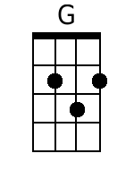  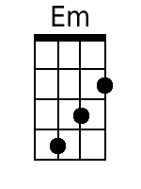  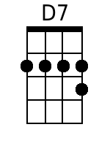  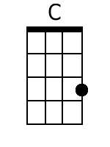  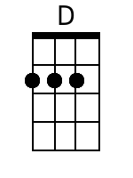  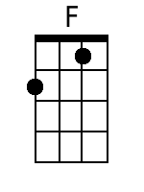  Bari  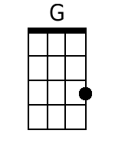  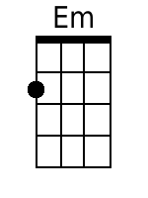  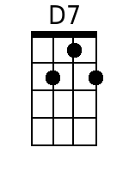  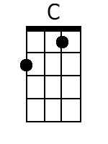  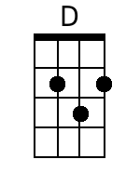  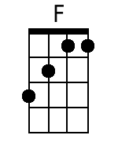 | Intro: G  G Em  Almost heaven, West Makaha,  D7 C G  High-ridge Mountains, crystal clear blue water  G Em  All my friends there, hanging on the beach,  D7 C G  Young and old among them, feel the ocean breeze  CHORUS:  G D7 Em C  Country road, take me home, To the place, I belong  G D7 C G  West Makaha, Mount Ka’ala, Take me home, oh country road  BRIDGE:  Em D G  I heard a voice, in the morning calm she calls me  C G D  As though to remind me of my home far a-way  Em F C  Driving down the road I feel the Spirit coming to me,  D D7  From yesterday, yesterday.  G Em  All my memories hold Heaven on high,  D7 C G  Brown skinned woman, clear blue island sky  G Em  Daytime sunshine, ooo-oh so bright,  D7 C G  Midnight moon a-glowing, stars up in the sky  CHORUS:  G D7 Em C  Country road, take me home, To the place, I belong  G D7 C G  West Makaha, Mount Ka’ala, Take me home, oh country road  BRIDGE:  Em D G  I heard a voice, in the morning calm she calls me  C G D  As though to remind me of my home far a-way  Em F C  Driving down the road I feel the Spirit coming to me,  D D7  From yesterday, yesterday.  G Em  Almost heaven, West Makaha,  D7 C G  High-ridge Mountains, crystal clear blue water  G Em  All my friends there, hanging on the beach,  D7 C G  Young and old among them, feel the ocean breeze  CHORUS:  G D7 Em C  Country road, take me home, To the place, I belong  G D7 C G  West Makaha, Mount Ka’ala, Take me home, oh country road  G D7 Em C  Country road, take me home, To the place, I belong  G D7 C G  West Makaha, Mount Ka’ala, Take me home, oh country road  D7 G D7 C G  Take me home, country roads, take me home, country ro - ads.

