**Take Me Out to the Ballgame Key C**

words and music by Harry von Tilzer and Jack Norworth 1908

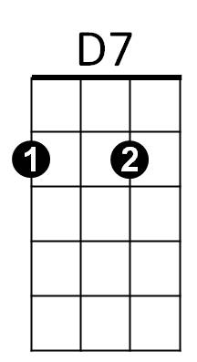**Intro : Melody last line of chorus**

F

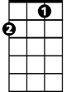

**C F**

Katie Casey was baseball mad, had the fever and had it bad

**G C D7 G7**

Just to root for the hometown crew, *every cent, Katie spent

**C F**

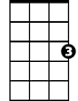

C

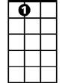

A7

On a Saturday her young beau, called to see if she’d like to go

**D7 G D7 G7**

To see a show but Miss Kate said no, I’ll tell you what you can do -

**CHORUS:**

**C G7 C G7**

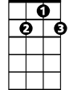

G7

Take me out to the ball game, take me out with the crowd

**A7 Dm D G7**

Buy me some peanuts and Crackerjack, I don’t care if I never get back

**C G7 C7 A7**

Let me root, root, root for the home team, if they don’t win, it’s a shame

**F D7 C A7 D7 G7 C**

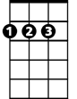

D

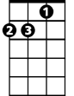

Dm

For it’s ONE, TWO, THREE strikes, you’re out at the old ball game

**C F**

Katie Casey saw all the games, knew the players by their first names

**G C D7 G7**

Told the umpire he was wrong, all along, good and strong

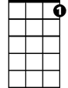

C7

**C F**

When the score was just two to two, Katie Casey knew what to do

**D7 G D7 G7**

Just to cheer up the boys she knew, she made the gang sing this song

**(CHORUS)**

**D7 G7 C TACET**

**Outro:** At the old...… ball…… Game! “PLAY BALL!”

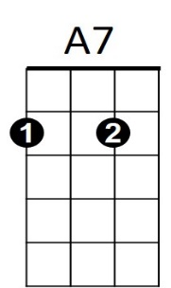



D7

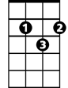

D

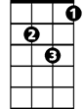

Dm

C



G7

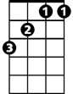

F

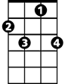

C7

**BARITONE**

<https://www.youtube.com/watch?v=q4-gsdLSSQ0> the original from 1908

**Take Me Out to the Ballgame Key G**

words and music by Harry von Tilzer and Jack Norworth 1908

**Intro : Melody last line of chorus**

E7

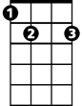

G

**G C**

Katie Casey was baseball mad, had the fever and had it bad

**D G A7 D7**

Just to root for the hometown crew, *every cent, Katie spent

**G C**

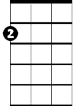

Am

On a Saturday her young beau, called to see if she’d like to go

**A7 D A7 D7**

To see a show but Miss Kate said no, I’ll tell you what you can do -

**CHORUS:**

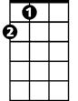

A

**G D7 G D7**

Take me out to the ball game, take me out with the crowd

**E7 Am A D7**

Buy me some peanuts and Crackerjack, I don’t care if I never get back

**G D7 G7 E7**

Let me root, root, root for the home team, if they don’t win, it’s a shame



G7



C

**C A7 G E7 A7 D7 G**

For it’s ONE, TWO, THREE strikes, you’re out at the old ball game

**G C**

Katie Casey saw all the games, knew the players by their first names

**D G A7 D7**



A7

Told the umpire he was wrong, all along, good and strong

**G C**

When the score was just two to two, Katie Casey knew what to do

**A7 D A7 D7**

Just to cheer up the boys she knew, she made the gang sing this song

**(CHORUS)**

**A7 D7 G TACET**

**Outro:** At the old...… ball…… Game! “PLAY BALL!”



C



G7



A



Am



E7



G



D7

**BARITONE**

<https://www.youtube.com/watch?v=q4-gsdLSSQ0> the original from 1908