**Take This Job And Shove It (David Allen Coe)**

**Chorus:**

**TACET**

Take this job and shove it

**F**

I ain't working here no more

**C**

My woman done left took all the reason

**D7 G7**

I was working for

**C**

Ya better not try to stand in my way

**F C**

As I'm walking out that door

**F C**

You can take this job and shove it

**G7 C**

I ain't working here no more

**C**

Well I been working in this factory

For now on fifteen years

**F**

All this time I watched my woman

**G7**

Drowning in a pool of tears

**C**

And I've seen a lot of good folks die

**F C**

Who had a lot of bills to pay

**F C**

I'd give the shirt right off of my back

**BARITONE**

**G C**

If I had the guts to say –

**(Chorus)**

**C**

The foreman he's a regular dog

The line boss he's a fool

**F**

He got a brand new flat top haircut

**G7**

Lord he thinks he's cool

**C**

One of these days I'm gonna blow my top

**F C**

And that sucker he's gonna pay

**F C**

I can't wait to see their faces

**G C**

When I get the nerve to say-

**(Chorus)**

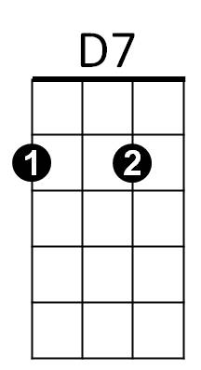

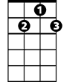

D7

C

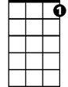

G7



F

F



C



G7