**Tell Laura I Love Her (Jeff Barry / Ben Raleigh) Key C**

**C F**

Laura and Tommy were lovers,

**C F**

He wanted to give her everything,

**Am Dm**

Flowers, presents,

**G G7**

And most of all a wedding-ring.

**C F**

He saw a sign for a stock-car race,

**C F**

A thousand dollar prize it read.

**Am Dm**

He couldn`t get Laura on the phone,

**G G7**

So to her mother Tommy said.

**C Dm**

Tell Laura, I love her, tell Laura, I need her**,**

**C**

Tell Laura, I may be late,

**Dm G C**

I`ve got something to do, that cannot wait.

**C F**

He drove his car to the racing ground,

**C F**

He was the youngest driver there.

**Am Dm**

The crowd roared as they started the race,

**G G7**

Round the track they dro ve at a deadly pace.

**C F**

No-one knows what happened that day,

**C F**

How his car overturned in flames.

**Am Dm**

But as they pulled him from the twisted wreck,

**G G7**

With his dying breath they heard him say.

**C Dm**

Tell Laura, I love her, tell Laura, I need her,

**C Dm**

Tell Laura not to cry, my love for her –

**G C**

Will never die**.**

**C F**

Now in the chapel Laura prays,

**C F**

For her Tommy who passed away,

**Am Dm**

It was just for Laura he lived and died,

**G G7**

Alone in the chapel she can hear him cry.

**C Dm**

Tell Laura, I love her, tell Laura, I need her,

**C Dm**

Tell Laura not to cry, my love for her –

**G C**

Will never die**.**

**BARITONE**

C



F



G

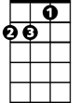

Dm



C

F

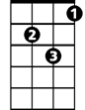

Dm



Am

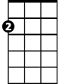

Am



G

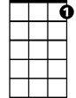

G7

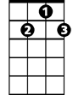

G7

**Tell Laura I Love Her (Jeff Barry / Ben Raleigh) Key G**

**G C**

Laura and Tommy were lovers,

**G C**

He wanted to give her everything,

**Em Am**

Flowers, presents,

**D D7**

And most of all a wedding-ring.

**G C**

He saw a sign for a stock-car race,

**G C**

A thousand dollar prize it read.

**Em Am**

He couldn`t get Laura on the phone,

**D D7**

So to her mother Tommy said.

**G Am**

Tell Laura, I love her, tell Laura, I need her**,**

**G**

Tell Laura, I may be late,

**Am D G**

I`ve got something to do, that cannot wait.

**G C**

He drove his car to the racing ground,

**G C**

He was the youngest driver there.

**Em Am**

The crowd roared as they started the race,

**D D7**

Round the track they drove at a deadly pace.

**G C**

No-one knows what happened that day,

**G C**

How his car overturned in flames.

**Em Am**

But as they pulled him from the twisted wreck,

**D D7**

With his dying breath they heard him say.

**G Am**

Tell Laura, I love her, tell Laura, I need her,

**G Am**

Tell Laura not to cry, my love for her –

**D G**

Will never die**.**

**G C**

Now in the chapel Laura prays,

**G C**

For her Tommy who passed away,

**Em Am**

It was just for Laura he lived and died,

**D D7**

Alone in the chapel she can hear him cry.

**G Am**

Tell Laura, I love her, tell Laura, I need her,

**G Am**

Tell Laura not to cry, my love for her –

**D G**

Will never die**.**



C



G



G

C



**BARITONE**

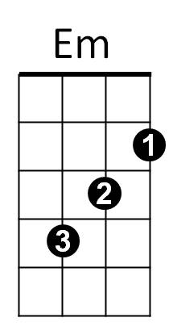



Am



Em



Am

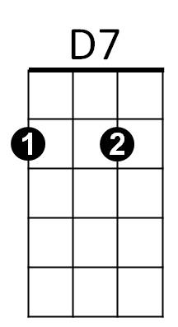

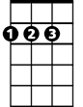

D



D



D7