Tell Me Why (John Lennon & Paul McCartney, 1964) (C)
Tell Me Why by The Beatles (D)
4/4 – 150 BPM

Intro Dm G7 | Dm G7 | Dm G7  Chorus  C Am Dm G7 C Dm  Tell me why you cried __ and why you lied to me.  G7 C Am Dm G7 C Dm  Tell me why you cried __ and why you lied to me.  G7 C Am Dm G7  Well, I gave you everything I had, but you left me sitting on my own  C Am Dm G7  Did you have to treat me oh so bad? All I do is hang my head and moan.  Chorus  G7 C Am Dm G7  If it's something that I've said or done. Tell me what, and I'll apolo-gize.  C Am Dm G7  If you don't I really can't go on, holding back these tears in my eyes.  Chorus  Bridge  C7 F  Well, I beg you on my bended knees,  G7  If you'll only listen to my pleas.  Am  Is there anything I can do?  Dm7 G7 C - G7  'Cause I really can't stand it, I'm so in love with you. Chorus  Outro G#7 G7 Dm C |  |  |  |  |  |  | 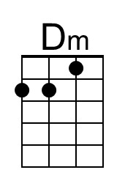
 |  |  |  |  |  |  | 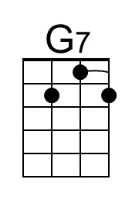
 |  |  |  |  |  |  | 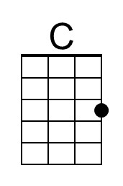
 |  |  |  |  |  |  | 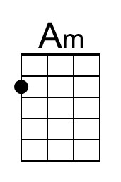
 |  |  |  |  |  |  | 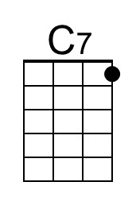
 |  |  |  |  |  |  | 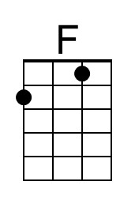
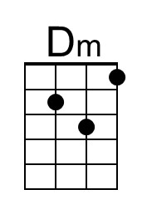 | 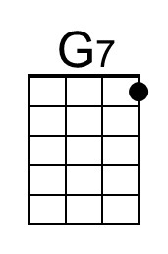 | 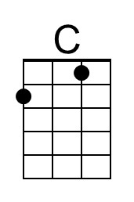 | 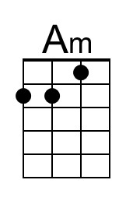 | 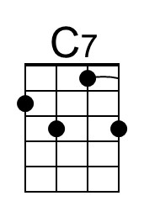 | 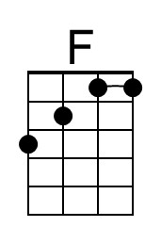 | 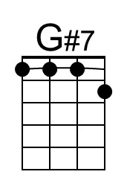 | 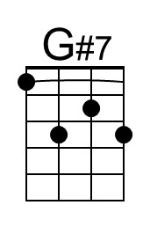

Tell Me Why (John Lennon & Paul McCartney, 1964) (D)
Tell Me Why by The Beatles (D)
4/4 – 150 BPM
Intro Em A7 | Em A7 | Em A7  Chorus  D Bm Em A7 D Em  Tell me why you cried __ and why you lied to me.  A7 D Bm Em A7 D Em  Tell me why you cried __ and why you lied to me.  A7 D Bm Em A7  Well, I gave you everything I had, but you left me sitting on my own  D Bm Em A7  Did you have to treat me oh so bad? All I do is hang my head and moan.  Chorus  A7 D Bm Em A7  If it's something that I've said or done. Tell me what, and I'll apolo-gize.  D Bm Em A7  If you don't I really can't go on, holding back these tears in my eyes.  Chorus  Bridge  D7 G  Well, I beg you on my bended knees,  A7  If you'll only listen to my pleas.  Bm  Is there anything I can do?  Em7 A7 D - A7  'Cause I really can't stand it, I'm so in love with you. Chorus  Outro Bb7 A7 Em D |  |  |  |  |  |  | 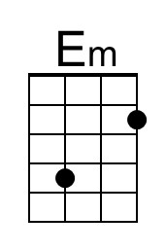
 |  |  |  |  |  |  | 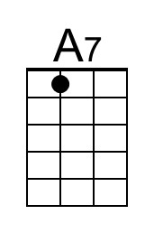
 |  |  |  |  |  |  | 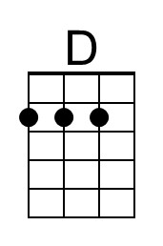
 |  |  |  |  |  |  | 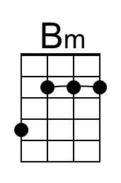
 |  |  |  |  |  |  | 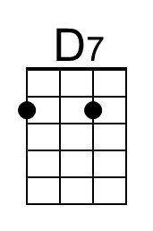
 |  |  |  |  |  |  | 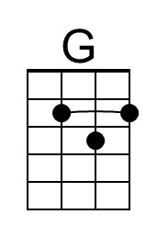
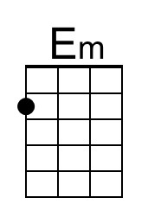 | 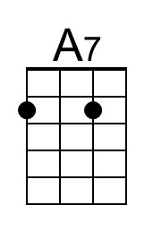 | 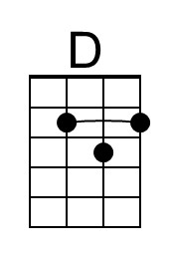 | 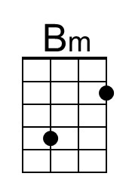 | 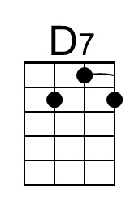 | 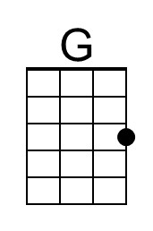 | 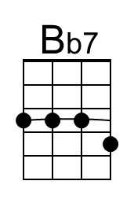 | 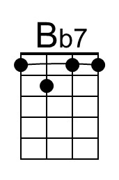

Tell Me Why (John Lennon & Paul McCartney, 1964) (G)
Tell Me Why by The Beatles (D)
4/4 – 150 BPM

Intro Am D7 | Am D7 | Am D7

Chorus
G Em Am D7 G Am
Tell me why you cried __ and why you lied to me.
D7 G Em Am D7 G Am
Tell me why you cried __ and why you lied to me.

D7 G Em Am D7
Well, I gave you everything I had, but you left me sitting on my own
G Em Am D7
Did you have to treat me oh so bad? All I do is hang my head and moan.
Chorus

D7 G Em Am D7
If it's something that I've said or done. Tell me what, and I'll apolo-gize.
G Em Am D7
If you don't I really can't go on, holding back these tears in my eyes.
Chorus
Bridge
G7 C
Well, I beg you on my bended knees,
D7
If you'll only listen to my pleas.
Em
Is there anything I can do?
Am7 D7 G - D7
'Cause I really can't stand it, I'm so in love with you. Chorus

Outro G#7 G7 Dm C

 |  |  |  |  |  | 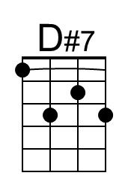 | 