Tell Me Why (John Lennon & Paul McCartney, 1964) (C)
Tell Me Why by The Beatles (D)
4/4 – 150 BPM
(Chords in Gray are optional)

Intro Dm G7 | Dm G7 | Dm G7 | Dm G7 |

Chorus
Dm7 G7 |C |Am |Dm7 |G7 Cm7 F7 |C Dm7
___ Tell me why __ you cried __ and why you lied to me.
G7 |C |Am |Dm7 |G7 Cm7 F7 |C Dm7
Tell me why __ you cried __ and why you lied to me.

G7 C Am Dm7 G7
Well, I gave you everything I had, but you left me sitting on my own
C Am Dm7 G7
Did you have to treat me oh so bad? All I do is hang my head and moan. Chorus

G7 C Am Dm7 G7
If it's something that I've said or done. Tell me what, and I'll apolo-gize.
C Am Dm7 G7
If you don't I really can't go on, holding back these tears in my eyes. Chorus

Bridge
C7 F7 G7
Well, I beg you on my bended knees, if you'll only listen to my pleas.
Am
Is there anything I can do?
Dm7 G7 C - G7
'Cause I really can't stand it, I'm so in love with you.

Dm7 G7 |C |Am |Dm7 |G7 Cm7 F7 |C Dm7
___ Tell me |why __ you cried __ and why you lied __ to me.
G7 |C |Am |Dm7 |G7 Dm7 |G7 Gm |
Tell me why __ you cried __ and why you lied__ to me.

Outro (Hold)
Am Ab | Gsus4-3 C

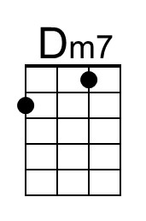 | 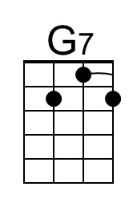 | 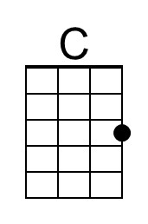 | 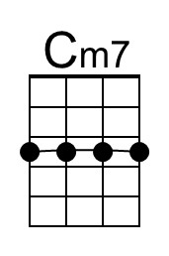 | 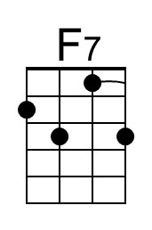 | 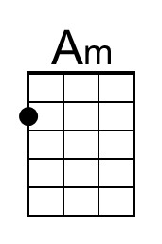 | 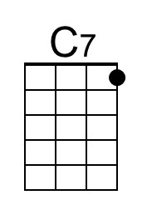 | 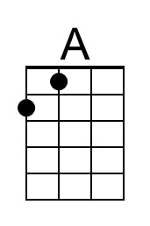 | 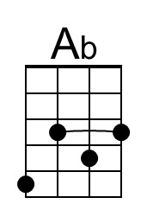 | 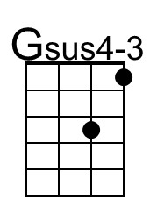
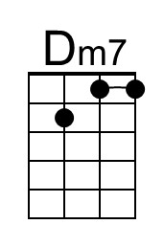 | 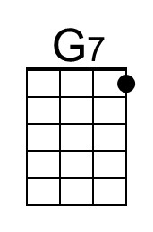 | 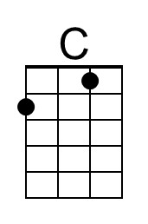 | 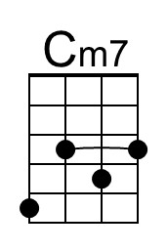 | 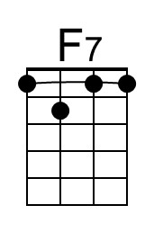 | 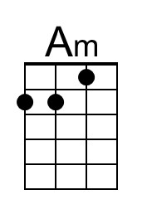 | 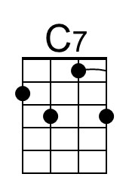 |  | 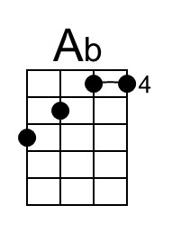 | 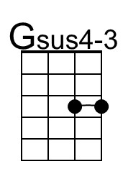

Tell Me Why (John Lennon & Paul McCartney, 1964) (D)
Tell Me Why by The Beatles (D)
4/4 – 150 BPM
(Chords in Gray are optional)

Intro Em7 A7 | Em7 A7 | Em7 A7 | Em7 A7 |

Chorus
Em7 A7 |D |Bm |Em7 |A7 Dm7 G7 |D Em7
___ Tell me why __ you cried __ and why you lied to me.
A7 |D |Bm |Em7 |A7 Dm7 G7 |D Em7
Tell me why __ you cried __ and why you lied to me.

A7 D Bm Em7 A7
Well, I gave you everything I had, but you left me sitting on my own
D Bm Em7 A7
Did you have to treat me oh so bad? All I do is hang my head and moan. Chorus

A7 D Bm Em7 A7
If it's something that I've said or done. Tell me what, and I'll apolo-gize.
D Bm Em7 A7
If you don't I really can't go on, holding back these tears in my eyes. Chorus

Bridge
D7 G7 A7
Well, I beg you on my bended knees, if you'll only listen to my pleas.
Bm
Is there anything I can do?
Em7 A7 D - A7
'Cause I really can't stand it, I'm so in love with you.

Em7 A7 |D |Bm |Em7 |A7 Dm7 G7 |D Em7
___ Tell me |why __ you cried __ and why you lied __ to me.
A7 |D |Bm |Em7 |A7 Em7 |A7 Am |
Tell me why __ you cried __ and why you lied__ to me.

Outro (Hold)
Bm Bb | Asus4-3 D

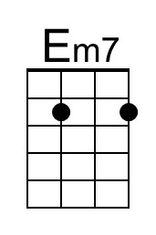 | 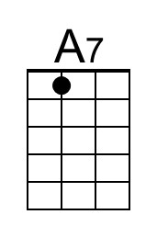 | 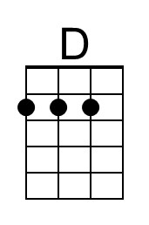 |  |  | 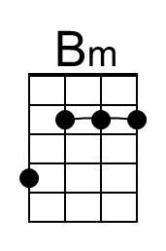 | 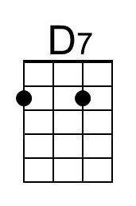 | 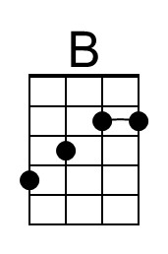 | 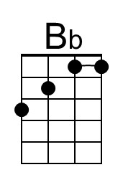 | 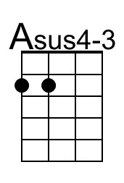
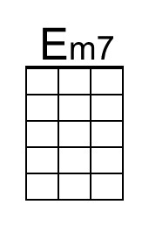 | 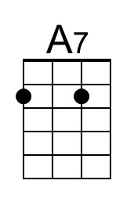 | 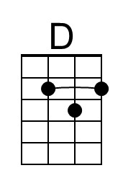 |  |  | 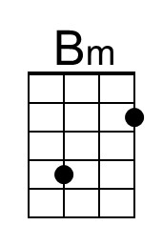 | 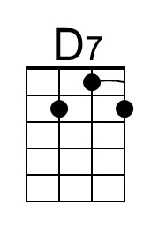 | 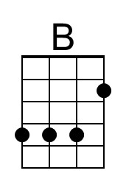 | 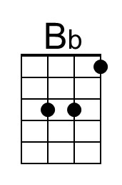 | 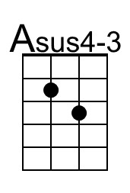

Tell Me Why (John Lennon & Paul McCartney, 1964) (G)
Tell Me Why by The Beatles (D)
4/4 – 150 BPM
(Chords in Gray are optional)

Intro Am D7 | Am D7 | Am D7 | Am D7 |

Chorus
Am7 D7 |G |Em |Am7 |D7 Gm7 C7 |G Am7
___ Tell me why __ you cried __ and why you lied to me.
D7 |G |Em |Am7 |D7 Gm7 C7 |G Am7
Tell me why __ you cried __ and why you lied to me.

D7 G Em Am7 D7
Well, I gave you everything I had, but you left me sitting on my own
G Em Am7 D7
Did you have to treat me oh so bad? All I do is hang my head and moan. Chorus

D7 G Em Am7 D7
If it's something that I've said or done. Tell me what, and I'll apolo-gize.
G Em Am7 D7
If you don't I really can't go on, holding back these tears in my eyes. Chorus

Bridge
G7 C7 D7
Well, I beg you on my bended knees, if you'll only listen to my pleas.
Em
Is there anything I can do?
Am7 D7 G - D7
'Cause I really can't stand it, I'm so in love with you.

Am7 D7 |G |Em |Am7 |D7 Gm7 C7 |G Am7
___ Tell me |why __ you cried __ and why you lied __ to me.
D7 |G |Em |Am7 |D7 Am7 |D7 Dm |
Tell me why __ you cried __ and why you lied__ to me.

Outro (Hold)
Em Eb | Dsus4-3 G

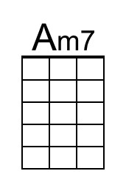 |  | 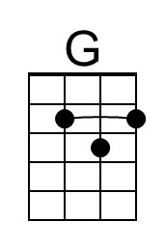 | 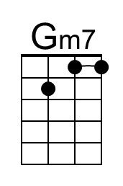 |  | 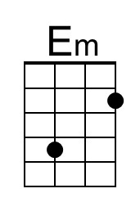 |  | 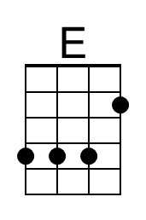 | 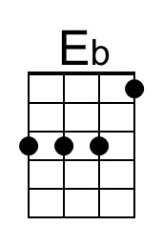 | 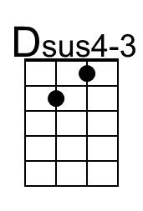
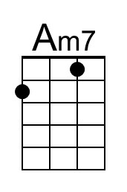 |  | 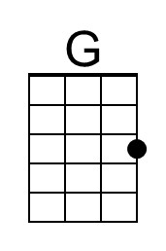 | 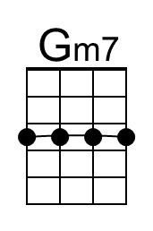 |  | 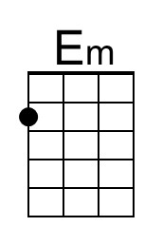 |  | 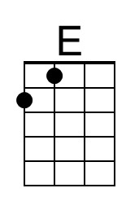 | 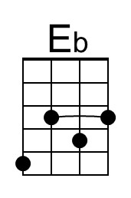 | 