**Tennessee Stud (James Driftwood)**

**G**

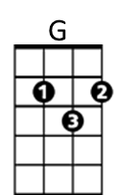Along about eighteen twenty-five,

**F**

I left Tennessee very much alive

**G**

And I never would have gotten through the Arkansas mud

**Dm G**

If I hadn't been a-ridin' that Tennessee stud

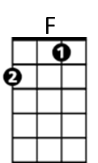**G**

I had some trouble with my sweetheart's pa,

**F**

And one of her brothers was a bad outlaw

**G**

I sent her a letter by my Uncle Fud

**Dm G**

Then I rode away on the Tennessee stud

**CHORUS:**

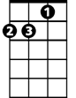

Dm

**G F G**

The Tennessee stud was long and lean

**C Bb D**

The color of the sun and his eyes were green

**G F G**

He had the nerve and he had the blood

**(tacet)**

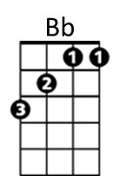And there never was a horse like the Tennessee stud

**G**

We drifted on down into no man's land

**F**

We crossed that river called the Rio Grande

**G**

I raced my horse with a Spaniard's foal

**Dm G**

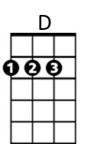'Til I got me a skin full of silver and gold

**G**

Me and the gambler, we couldn't agree

**F**

We got in a fight over Tennessee

**G**

We jerked our guns and he fell with a thud

**Dm G**

And I got away on the Tennessee stud

**(CHORUS)**

**G**

Well, I got just as lonesome as a man can be

**F**

A-dreaming of my girl in Tennessee

**G**

The Tennessee stud's green eyes turned blue

**Dm G**

**BARITONE**

'Cause he was a-dreamin' of his sweetheart, too

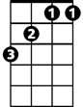

F



G

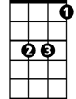

Bb

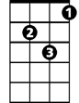

Dm



D

**G**

We loped right back across Arkansas

**F**

I whooped her brother and I whooped her pa

**G**

When I found that girl with the golden hair

**Dm G**

And she was a-ridin' that Tennessee mare (whoa, boy)

**(CHORUS)**

**G**

Stirrup to stirrup and side by side

**F**

We crossed them mountains and the valleys wide

**G**

We came to Big Muddy then we forded a flood

**Dm G**

On the Tennessee mare and the Tennessee stud

**G**

There's a pretty little baby on the cabin floor

**F**

A little horse colt playin' 'round the door

**G**

I love that girl with golden hair

**Dm G**

And the Tennessee stud loves the Tennessee mare (They'se good horses)

**(CHORUS)**

**Tennessee Stud (James Driftwood) Key A**

**A**

****Along about eighteen twenty-five,

**G**

I left Tennessee very much alive

**A**

And I never would have gotten through the Arkansas mud

**Em A**

If I hadn't been a-ridin' that Tennessee stud

**A**

I had some trouble with my sweetheart's pa,

**G**

And one of her brothers was a bad outlaw

**A**

I sent her a letter by my Uncle Fud

**Em A**

Then I rode away on the Tennessee stud

**CHORUS:**



Dm

**A G A**

The Tennessee stud was long and lean

**D C E**

The color of the sun and his eyes were green

**A G A**

He had the nerve and he had the blood

**(tacet)**

And there never was a horse like the Tennessee stud

**A**

We drifted on down into no man's land

**G**

We crossed that river called the Rio Grande

**A**

I raced my horse with a Spaniard's foal

**Em A**

'Til I got me a skin full of silver and gold

**A**

Me and the gambler, we couldn't agree

**G**

We got in a fight over Tennessee

**A**

We jerked our guns and he fell with a thud

**Em A**

And I got away on the Tennessee stud

**(CHORUS)**

**A**

Well, I got just as lonesome as a man can be

**G**

A-dreaming of my girl in Tennessee

**A**

The Tennessee stud's green eyes turned blue

**Em A**

**BARITONE**

'Cause he was a-dreamin' of his sweetheart, too



F



G



Bb



Dm



D

**A**

We loped right back across Arkansas

**G**

I whooped her brother and I whooped her pa

**A**

When I found that girl with the golden hair

**Em A**

And she was a-ridin' that Tennessee mare (whoa, boy)

**(CHORUS)**

**A**

Stirrup to stirrup and side by side

**G**

We crossed them mountains and the valleys wide

**A**

We came to Big Muddy then we forded a flood

**Em A**

On the Tennessee mare and the Tennessee stud

**A**

There's a pretty little baby on the cabin floor

**G**

A little horse colt playin' 'round the door

**A**

I love that girl with golden hair

**Em A**

And the Tennessee stud loves the Tennessee mare (They'se good horses)

**(CHORUS)**