**Tequila Sunrise (Don Henly / Glenn Frey) Key C**

**Intro: Chords for ending**

**C**

It's another tequila sunrise

**G Dm**

Starin' slowly cross the sky -

**G7 C**

I said good-bye.

**C**

He was just a hired hand

**G Dm**

Workin' on the dreams he planned to try -

**G7 C**

The days go by

**Am F**

Every night when th e sun goes down

**Am F Am**

Just another lonely boy in town

**Dm G7**

And she's out runnin' rou - nd

**C**

She wasn’t just another woman

**G Dm**

And I couldn’t keep from coming' on -

**G7 C**

It's been so long

**C**

Oh and it's a hollow feelin'

**G Dm**

When it comes down to dealin' friends -

**BARITONE**

**G7 C**

It never ends.

**Instrumental verse**

**Dm G**

Take another shot of courage

**Em Am Dm**

Wonder why the right words never come -

**E7 Am7 D**

You just get numb

**Ending:**

**C**

It's another tequila sunrise

**G Dm**

This old world still looks the same ~

**G7 C**

Another frame.

**(strum C to fade)**



G

Em

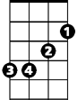

E7

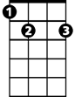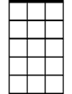

Am7

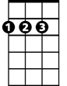

D

F

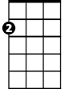

Am

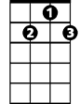

G7

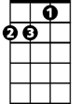

Dm



C



Am

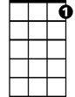

G7

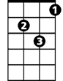

Dm



G

C



D



Em

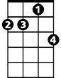

Am7

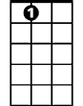

E7



F

**Tequila Sunrise (Don Henly / Glenn Frey) Key G**

**Intro: Chords for ending**

**G**

It's another tequila sunrise

**D Am**

Starin' slowly cross the sky -

**D7 G**

I said good-bye.

**G**

He was just a hired hand

**D Am**

Workin' on the dreams he planned to try -

**D7 G**

The days go by

**Em C**

Every night when the sun goes down

**Em C Em**



C

Just another lonely boy in town

**Am D7**

And she's out runnin' rou - nd

**G**

She wasn’t just another woman

Em



**D Am**

And I couldn’t keep from coming' on -

**D7 G**

It's been so long

**G**

Oh and it's a hollow feelin'

**D Am**

**BARITONE**

When it comes down to dealin' friends



G

**D7 G**

It never ends.

**Am D**

Take another shot of courage

**Bm Em Am**

Wonder why the right words never come -

**B7 Em7 A**

You just get numb

**Ending:**

**G**

It's another tequila sunrise

**D Am**

This old world still looks the same ~

**D7 G**

Another frame.

**Strum G to fade**



G



D



Am

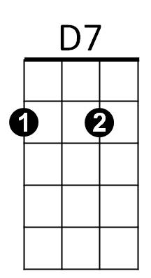

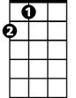

A

Em7

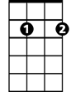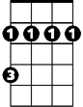

Bm

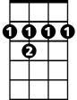

B7



D



Am



D7



Em

**Instrumental verse**

C



Bm



B7



Em7



A