That’s A Moray! (F)
Parody of “That’s Amore” (Harry Warren & Jack Brooks, 1953)
That’s Amore by Dean Martin
Compilation From Various Internet Sources By Theresa Miller

F C7 F  When – you’re – down by the sea and an eel bites your knee,  C7  That’s a Moray (a moray!)  C7  Put your hand in a crack and you won’t get it back,  F  From a Moray (from a moray!)  C7 F  He can swim, he can glide but he would rather hide  C7  In the coral (in the coral)  C7  If you dive, stay alive, listen to me,  F  For there is a MORAL (there’s a moral)  F C7 F  See - that - thing in the reef with the big shiny teeth,  C7  That’s a Moray (that’s a moray!)  C7  From his hole in the reef,  C7 Dm  He will bring you much grief, that’s for sure.  Bb Gm7  He’s hun-gry, and you see, you are the meal  F  That he will adore-ay (adore-ay)  C7 F  ‘Scusa me, but you see, let him be, or there’ll be lotsa Morays (lotsa morays!)  Bari |  |  |  |  |  |         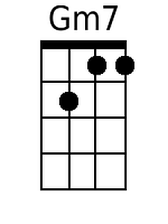
 |  |  |  | 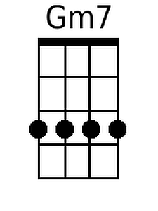

That's A Moray (F) – Page 2

F C7 F C7
When – a – fish bites your heel and it looks like and eel, that’s a Moray (that’s a moray!)
C7 F
Down be-low we all know he’s that meanie, they call him a Moray (a moray!)

F C7 F C7
If – you – see a big eel and his teeth are like steel, that’s a Moray (that’s a moray!)
C7 F
If he’s big and he’s mean, and he’s spotty or green, that’s a Moray (that’s a moray!)

F C7 F C7
If – you – reach in his cave, suddenly you’ll need saved from a Moray (from a Moray!)
C7 Dm
When he’s fanning his gills, better head for the hills, that’s for sure.
Bb Gm7 F
He’s hungry, and you see, you are the meal that he will a-dore-ay (adore-ay)
C7 F
‘Scusa me, but you see, let him be, or there’ll be lotsa morays (lotsa morays!)

C7 F - C7 ↓ F ↓
‘Scusa me, but you see, let him be, JUST DON’T MESS WITH A MORAY!

