That’s a Moray!
Parody song of 'That’s Amore'
Compilation from various internet sources

F C7 F  When – you’re – down by the sea and an eel bites your knee,  C7  That’s a Moray (a moray!)  C7  Put your hand in a crack and you won’t get it back,  F  From a Moray (from a moray!)  C7 F  He can swim, he can glide but he would rather hide  C7  In the coral (in the coral)  C7  If you dive, stay alive, listen to me,  F  For there is a MORAL (there’s a moral)  F C7 F  See - that - thing in the reef with the big shiny teeth,  C7  That’s a Moray (that’s a moray!)  C7  From his hole in the reef,  C7 Dm  He will bring you much grief, that’s for sure.  Bb Gm7  He’s hun-gry, and you see, you are the meal  F  That he will adore-ay (adore-ay)  C7  ‘Scusa me, but you see, let him be,  F  Or there’ll be lotsa Morays (lotsa morays!)  Bari |  |  |  |  |  | 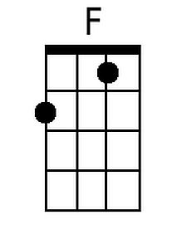  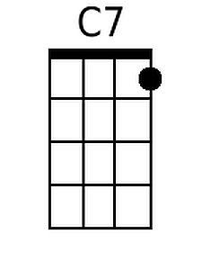  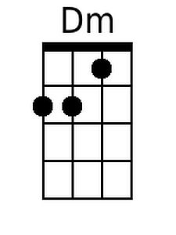  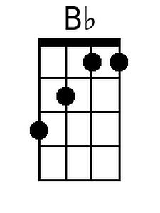  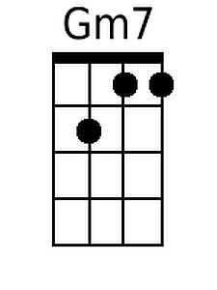
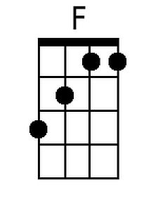 | 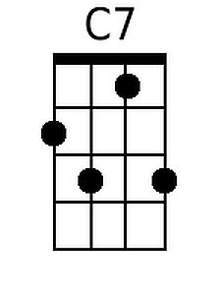 | 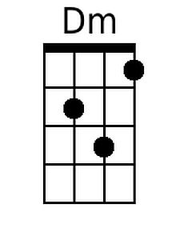 | 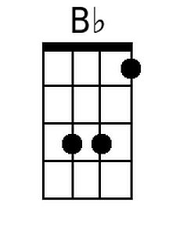 | 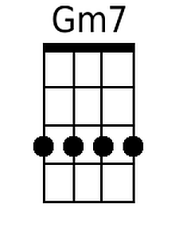

That's A Moray – Page 2

Verse 2
F C7 F
When – a - fish bites your heel and it looks like and eel,
C7
that’s a Moray (that’s a moray!)
C7
Down be-low we all know he’s that meanie,
F
They call him a Moray (a moray!)
C7 F
If you see a big eel and his teeth are like steel,
C7
That’s a Moray (that’s a moray!)
C7
If he’s big and he’s mean, and he’s spotty or green,
F
That’s a Moray (that’s a moray!)

F C7 F
If - you - reach in his cave, suddenly you’ll need saved
C7
From a Moray (from a Moray!)
C7
When he’s fanning his gills, better head for the hills,
Dm
That’s for sure
Bb Gm7
He’s hungry, and you see, you are the meal
F
That he will adore-ay (adore-ay)
C7
‘Scusa me, but you see, let him be,
F
Or there’ll be lotsa morays (lotsa morays!)

C7
‘Scusa me, but you see, let him be,
F C7/ F/
JUST DON’T MESS WITH A MORAY!

