The Ballad Of Davy Crockett (George Bruns & Thomas W. Blackburn, 1954) (C)

C F C  Born on a mountain top in Ten-nes-see,  C D7 G7  Greenest state in the land of the free.  C C7 F D7  Raised in the woods so he knew every tree.  G7 C  Killed him a b'ar when he was only three.  C F C G G7 C  Davy, Davy Crockett, king of the wild fron-tier.  C F C  Fought single handed through the Indian war,  C D7 G7  Till' the Creeks were whipped and peace was in store,  C C7 F D7  While he was handling this risky chore,  G7 C  Made himself a legend forever more.  C F C G G7 C  Davy, Davy Crockett, the man who don't know fear.  C F C  He went off to Congress and served a spell,  C D7 G7  Fixin' up the government and laws as well,  C C7 F D7  He took over Washington so I hear tell  G7 C  And patched up the crack in the Liberty Bell.  C F C G G7 C  Davy, Davy Crockett, seeing his duty clear. |  |  |  |  | C F C  When he come home, his politickin' done,  C D7 G7  Why the westward march had just be-gun,  C C7 F D7  So he packed his gear and his trusty gun  G7 C  And lit out a grinnin' to follow the sun.  C F C G G7 C  Davy, Davy Crockett, a leadin' a pio-neer.  C F C  He heard of Houston and Austin and so,  C D7 G7  To the Texas plains he just had to go,  C C7 F D7  Their freedom was fightin' a-nother foe  G7 C  And they needed him at the Ala-mo!  C F C G G7 C  Davy, Davy Crockett, king of the wild fron-tier.…
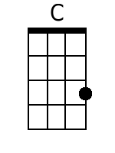 | 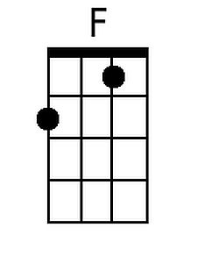 | 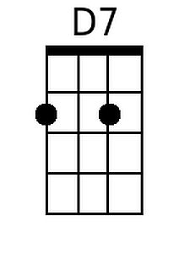 | 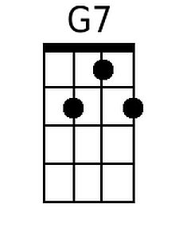 | 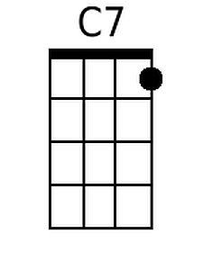
Bari
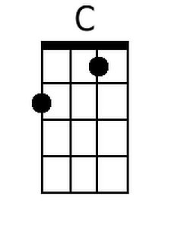 | 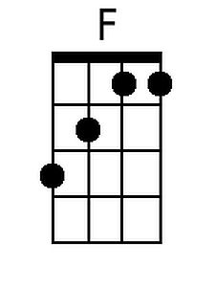 | 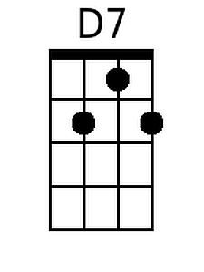 | 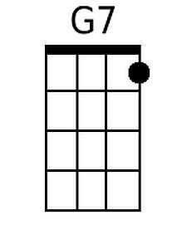 | 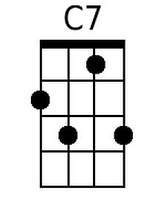

The Ballad Of Davy Crockett (George Bruns & Thomas W. Blackburn, 1954) (G)

G C G  Born on a mountain top in Ten-nes-see,  G A7 D7  Greenest state in the land of the free.  G G7 C A7  Raised in the woods so he knew every tree.  D7 G  Killed him a b'ar when he was only three.  G C G D D7 G  Davy, Davy Crockett, king of the wild fron-tier.  G C G  Fought single handed through the Indian war,  G A7 D7  Till' the Creeks were whipped and peace was in store,  G G7 C A7  While he was handling this risky chore,  D7 G  Made himself a legend forever more.  G C G D D7 G  Davy, Davy Crockett, the man who don't know fear.  G C G  He went off to Congress and served a spell,  G A7 D7  Fixin' up the government and laws as well,  G G7 C A7  He took over Washington so I hear tell  D7 G  And patched up the crack in the Liberty Bell.  G C G D D7 G  Davy, Davy Crockett, seeing his duty clear. |  |  |  |  | G C G  When he come home, his politickin' done,  G A7 D7  Why the westward march had just be-gun,  G G7 C A7  So he packed his gear and his trusty gun  D7 G  And lit out a grinnin' to follow the sun.  G C G D D7 G  Davy, Davy Crockett, a leadin' a pio-neer.  G C G  He heard of Houston and Austin and so,  G A7 D7  To the Texas plains he just had to go,  G G7 C A7  Their freedom was fightin' a-nother foe  D7 G  And they needed him at the Ala-mo!  G C G D D7 G  Davy, Davy Crockett, king of the wild fron-tier.
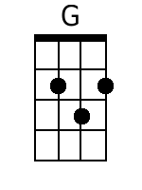 |  | 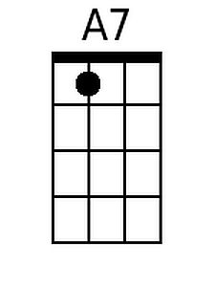
Bari
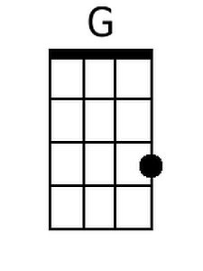 |  | 