The Ballad of Gilligan's Isle (Am)
(Sherwood Schwartz & George Wyle, 1964)
The Ballad of Gilligan's Island by The Wellingtons & The Eligibles

Intro: Strum in on Am  Am G Am G  Just sit right back and you'll hear a tale, a tale of a fateful trip,  Am G F G Am  That started from this tropic port, a-board this tiny ship.  Am G Am G  The mate was a mighty sailin' man, the skipper brave and sure,  Am G F G Am F G Am  Five passengers set sail that day, for a three hour tour, a three hour tour.  Am G Am G  The weather started getting rough, the tiny ship was tossed.  Am G  If not for the courage of the fearless crew,  F G Am F G Am  The Minnow would be lost, the Minnow would be lost.  Am G Am G  The ship's aground on the shore of this un-charted desert isle,  Am G Am G  With Gilligan, the Skipper, too, the Millionaire and his wife,  Am G Am G F G Am  The movie star…the Professor and Mary-Ann here on Gilligan's Isle!  Am G Am G  So this is the tale of our castaways, they're here for a long, long time.  Am G F G Am  They'll have to make the best of things, it's an uphill climb.  Am G Am G  The first mate and his skipper, too, will do their very best,  Am G F G Am  To make the others comfortable, in the tropic island nest.  Am G Am G  No phones, no lights, no motor cars, not a single luxu-ry.  Am G F G Am  Like Robinson Cru-soe, it's primitive as can be.  Am G Am G  So join us here each week my friend, you're sure to get a smile.  Am G F G Am  From seven stranded castaways, here on Gilligan's Isle,  F G Am F G Am Am  Here on Gilligan's Isle, Here on Gilligan's Isle. | 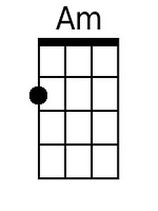
 | 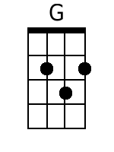
 | 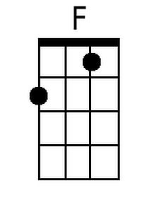
 | Baritone
 | 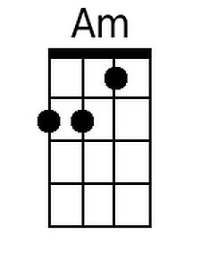
 | 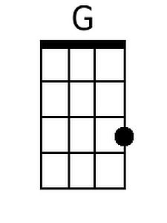
 | 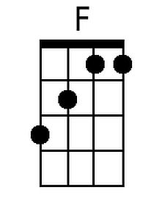

The Ballad of Gilligan's Isle (Em)
(Sherwood Schwartz & George Wyle, 1964)
The Ballad of Gilligan's Island by The Wellingtons & The Eligibles

Intro: Strum in on Em  Em D Em D  Just sit right back and you'll hear a tale, a tale of a fateful trip,  Em D C D Em  That started from this tropic port, a-board this tiny ship.  Em D Em D  The mate was a mighty sailin' man, the skipper brave and sure,  Em D C D Em C D Em  Five passengers set sail that day, for a three hour tour, a three hour tour.  Em D Em D  The weather started getting rough, the tiny ship was tossed.  Em D  If not for the courage of the fearless crew,  C D Em C D Em  The Minnow would be lost, the Minnow would be lost.  Em D Em D  The ship's aground on the shore of this un-charted desert isle,  Em D Em D  With Gilligan, the Skipper, too, the Millionaire and his wife,  Em D Em D C D Em  The movie star the Professor and Mary-Ann here on Gilligan's Isle!  Em D Em D  So this is the tale of our castaways, they're here for a long, long time.  Em D C D Em  They'll have to make the best of things, it's an uphill climb.  Em D Em D  The first mate and his skipper, too, will do their very best,  Em D C D Em  To make the others comfortable, in the tropic island nest.  Em D Em D  No phones, no lights, no motor cars, not a single luxu-ry.  Em D C D Em  Like Robinson Cru-soe, it's primitive as can be.  Em D Em D  So join us here each week my friend, you're sure to get a smile.  Em D C D Em  From seven stranded castaways, here on Gilligan's Isle,  C D Em C D Em Em  Here on Gilligan's Isle, Here on Gilligan's Isle. | 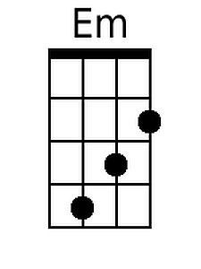
 | 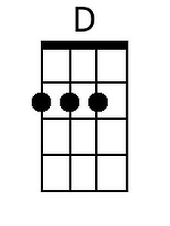
 | 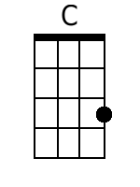
 | Baritone
 | 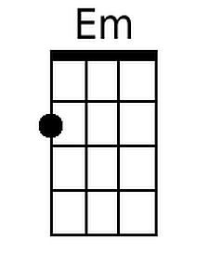
 | 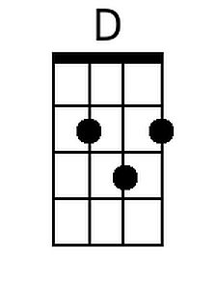
 | 