The Ballad of Jed Clampett (Paul Henning, 1962)
Theme From The Beverly Hillbillies, Foggy Mountain Boys

Intro: Strum in on C  C Dm G  Come 'n listen to my story 'bout a man named Jed  C  A poor mountaineer, barely kept his family fed  F F#º7  And then one day, he was shootin' at some food  G C  And up through the ground come a bubblin' crude  C  Oil, that is, black gold, Texas tea.  C Dm G  Well, the first thing you know, old Jed's a million-aire  C  Kin folk said, Jed, move away from there  F F#º7  Said, Californy is the place you oughta be  G C  So they loaded up the truck and they moved to Bever-ly  C C G C  Hills, that is, swimmin' pools, movie stars (STOP)  Instrumental Verse  C Dm G  Well, now it's time to say goodbye to Jed and all his kin  C  They would like to thank you folks for kindly droppin' in  F F#º7  You're all invited back again to this locali-ty  G C  To have a heapin' helpin' of their hospitali-ty  C  Hillbilly, that is, set a spell, take your shoes off  C G C  Y'all come back now, hear? |  |  |  |  |  |  |  | 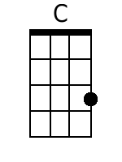
 |  |  |  |  |  |  |  | 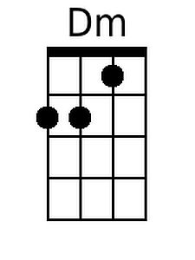
 |  |  |  |  |  |  |  | 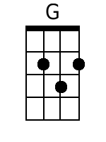
 |  |  |  |  |  |  |  | 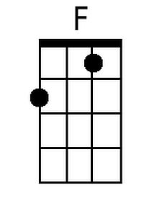
 |  |  |  |  |  |  |  | 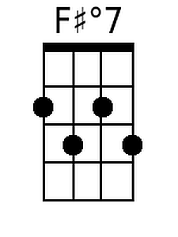
Baritone
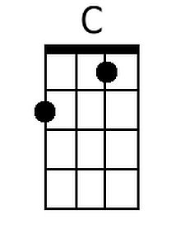 | 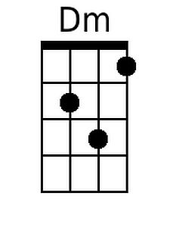 | 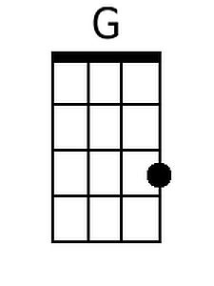 | 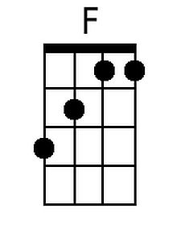 | 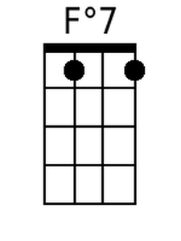

The Ballad of Jed Clampett (Paul Henning, 1962)
Theme From The Beverly Hillbillies, Foggy Mountain Boys

Intro: Strum in on G

G Am D
Come 'n listen to my story 'bout a man named Jed
G
A poor mountaineer, barely kept his family fed
C C#º7
And then one day, he was shootin' at some food
D G
And up through the ground come a bubblin' crude
G
Oil, that is, black gold, Texas tea.

G Am D
Well, the first thing you know, old Jed's a million-aire
G
Kin folk said, Jed, move away from there
C C#º7
Said, Californy is the place you oughta be
D G
So they loaded up the truck and they moved to Bever-ly
G G D G
Hills, that is, swimmin' pools, movie stars (STOP)

Instrumental Verse

G Am D
Well, now it's time to say goodbye to Jed and all his kin
G
They would like to thank you folks for kindly droppin' in
C C#º7
You're all invited back again to this locali-ty
D G
To have a heapin' helpin' of their hospitali-ty
G
Hillbilly, that is, set a spell, take your shoes off
G D G
Y'all come back now, hear?

 |  |  |  |  |  |  |  | 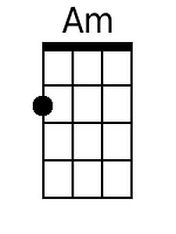
 |  |  |  |  |  |  |  | 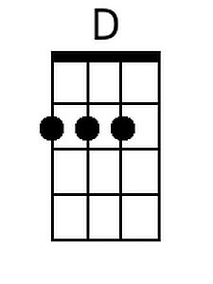
 |  |  |  |  |  |  |  | 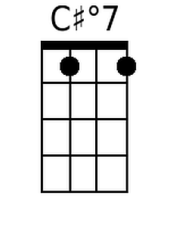
Baritone
 | 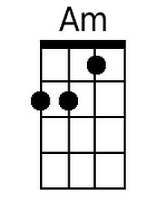 | 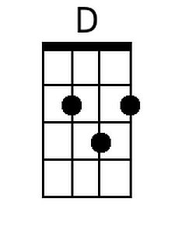 |  | 