The Ballad of Paladin (Sam Rolfe, Richard Boone & Johnny Western, 1957)
for the television series "Have Gun, Will Travel" 1957-1963, and for the radio series, 1958-1960

C F C
Paladin, Paladin, where do you roam
F C
Paladin, Paladin, far, far from home

C G7 C
Have gun will travel reads the card of a man
G7 C
A knight without armor in a savage land
Am F C
His fast gun hire heeds the calling wind
F C
A soldier of fortune is a man called Paladin

C F C
Paladin, Paladin, where do you roam
F C
Paladin, Paladin, far, far from home

C G7 C
He travels on to where ever he must
G7 C
A chess knight of silver is his badge of trust
Am F C
There are campfire legends that the plainsmen sing
F C
Of the man with the gun of the man called Paladin

C F C
Paladin, Paladin, where do you roam
F C
Paladin, Paladin, far, far from home

F C F C
Far, far, from home - far, far, from home

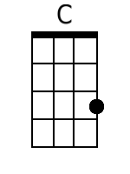 | 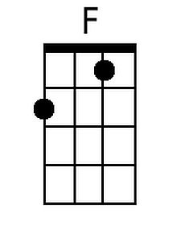 | 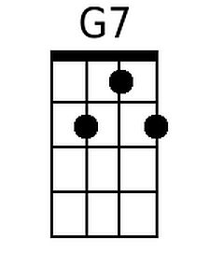 | 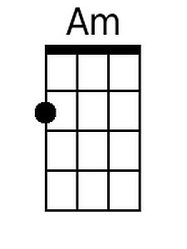 | Bari | 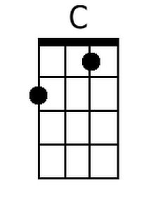 | 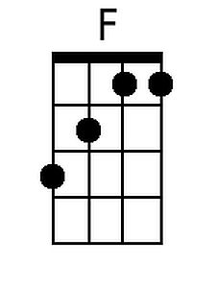 | 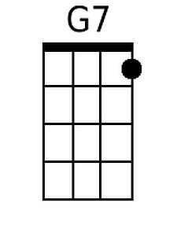 | 